**Contact:** Jim Rockwell **FOR IMMEDIATE RELEASE**

**Tel:** 201-247-7224

**Email:** marketing@rbimusic.com

**Toca Introduces New Hardware Solutions to Longstanding Setup Challenges**

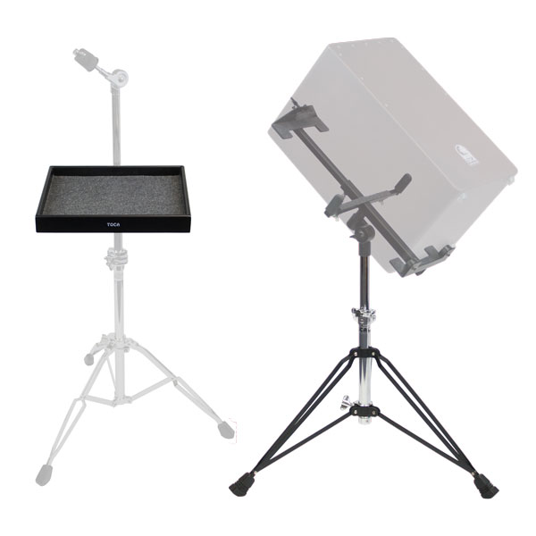The problem solvers at Toca have further expanded the legendary brand’s hardware options in 2019 with the launch of two practical solutions that address longstanding setup challenges for both drummers and percussionists, as well as any instrumentalist or vocalist who wants to keep small hand percussion instruments within reach. Introduced at the 2019 Winter NAMM show, these include:

• **Cajon Stand.** Since it’s traditionally played while sitting on top of the box-like instrument with legs straddling opposite sides, the cajon has posed a puzzle for percussionists or any on-stage performer who want to position one for quick and easy access while standing within an elaborate setup.

Toca’s new Cajon Stand makes it simple. Its heavy-duty, black powder-coated mounting system securely grips nearly any sized cajon with dense closed-foam cushioned arms that protect the tone wood and enhance its resonance. A gear-tooth tilter offers a wide sweep of angles to suit any playing style and works in tandem with the height-adjustable stand to position the instrument in even the busiest setups.

• **Stand-Mountable Percussion Tray – Small**. Easily attached to the vertical tubes of most percussion stands, this all-purpose tray keeps handheld instruments like shakers or tambourines arranged and within close reach. Drum set players will also find it equally useful as a handy drumstick and drink holder when mounted from a hi-hat or crash cymbal stand.

Like all Toca hardware, it’s built to last, with 360-degree raised edges surrounding a textured-surface liner to keep loose instruments secure and in place during performances. The tray’s compact size makes it a cinch to put it exactly where it needs to go and, combined with its black motif, helps it blend into the background from the audience’s perspective.

**Cajon Stand** (T-CAJSTD)= $234.99 Retail/MSRP, $149.99 MAP/Street

**Percussion Tray – Small, Stand-Mountable** (T-TRAY-SM)= $99.99 Retail/MSRP, $63.99 MAP/Street

tocapercussion.com