**Contact:** Jim Rockwell **FOR IMMEDIATE RELEASE**

**Tel:** 201-247-7224

**Email:** marketing@rbimusic.com

**New Toca Percussion Mounts Provide Perfect Positioning**

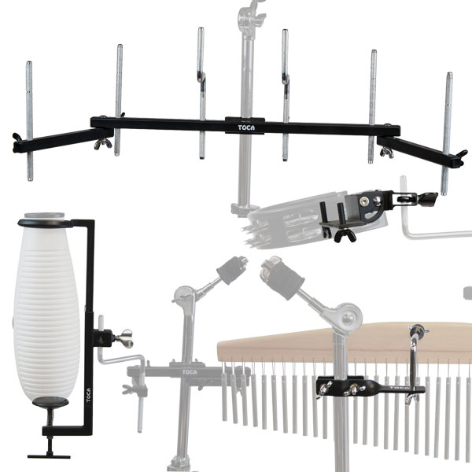Whether seated behind a drum kit or surrounded by a world percussion rig, drummers of all stripes have good reasons to celebrate after Toca introduced a new series of adaptable percussion mounts at the 2019 Winter NAMM Show. Constructed of cold-rolled steel that is equally strong and lightweight, these new mounts are designed to eliminate the hassle of fitting instruments into tight setups. Models include:

• **Accessory Mounts**. Ideal for adding a cowbell, tone block, or other small percussion accessory to any rig, these mounts feature a sturdy frame fitted with adjustable knurled chrome rods to suspend a wide range of instruments. When fastened to a common microphone or percussion stand with tube diameters ranging from 3/8" to 1-1/8", Accessory Mounts can be unfolded to increase the number of available attachments: The 2/4 model secures either two or four percussion instruments while the 4/6 version mounts four or six.

• **Chime & Guiro Mounts**. Contoured and black powder-coated to be discreet under stage lights, these two heavy-duty mounts clamp their respective instruments firmly while visually disappearing into a busy setup. Attached to common percussion stands with tube diameters ranging from 3/8" to 1-1/8", their robust design will withstand spirited performances while requiring only a minimal amount of set-up space. The Chime Mount attaches to the back of the instrument frame via a single point of contact while the Guiro Mount cradles the gourd shell with an upper ring and lower clamp that are both rubberized to protect the instrument from damage.

• **Universal Tambourine/Frame Drum Mount**. This ultra-compact mount makes it easier than ever to place a frame drum or tambourine within easy reach of a drum stick, mallet, or hand slap. Featuring rubberized retaining pegs that prevent scratches or damage to the instrument, its high-strength right-angle clamp enables precise positioning, and makes minimal contact with the shell to ensure unrestricted resonance. The mount attaches and detaches in a split second, and provides a snug 360-degree grip onto any cymbal topper or 3/8" rod for worry-free performance.

**Accessory Mount 2/4** (T-ACCMT-2/4) = $99 (MSRP)/$63.99 (MAP); **4/6** (T-ACCMT-4/6) = $119.99 (MSRP)/$76.99 (MAP)

**Toca Chime Mount** (T-CHMT) = $24.99 (MSRP)/$15.99 (MAP)

**Toca Guiro Mount** (T-GUMT) = $79.99 (MSRP)/$50.99 (MAP)

**Universal Tambourine/Frame Drum Mount** (T-UTAMMT) = $38.39 (MSRP)/$24.99 (MAP)

tocapercussion.com