**Contact:** Jim Rockwell **FOR IMMEDIATE RELEASE**

RBI Music

**Tel:** 201-247-7224

**Email:** jim@filamentsolutions.com

**Odery Introduces Dark Wine Burst Finish for Fluence Fusion Kits**

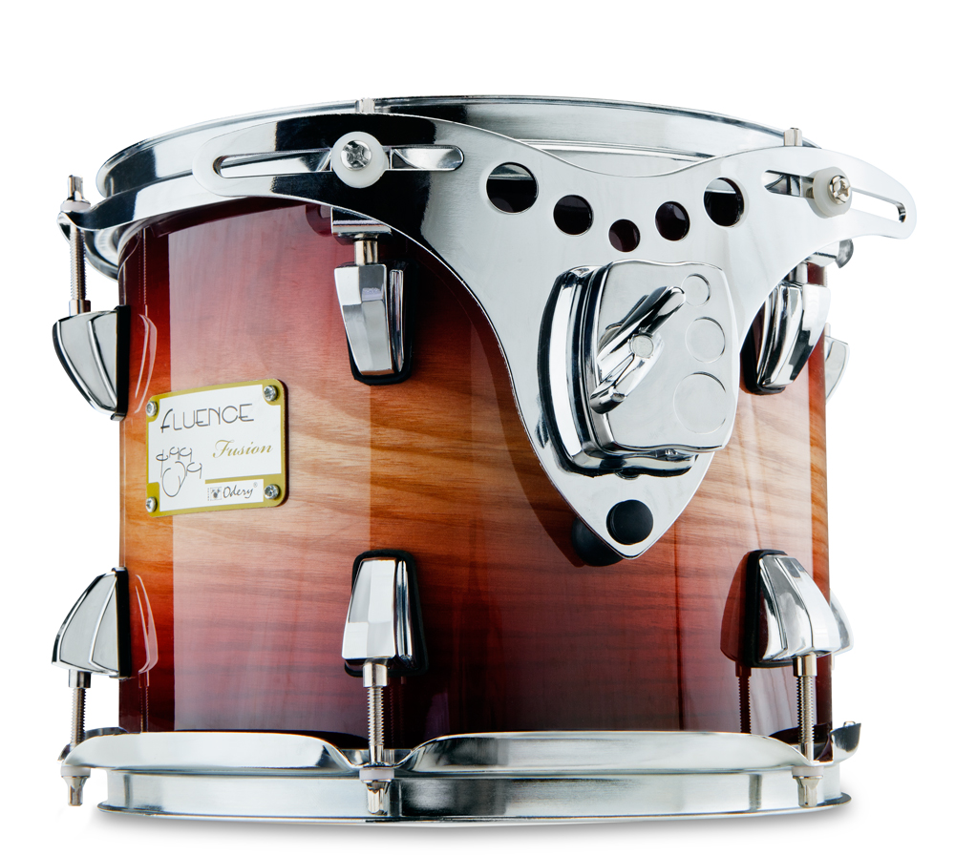

Having won international acclaim for building fine instruments from exotic wood species, Odery introduced the moderately priced Fluence Fusion drum kit to its growing legion of fans in 2011. Now the legendary Brazilian drum maker further expands the series by introducing the new Dark Wine Burst to the U.S. — a rich lacquer finish as lustrous as its name, which gently fades from a reddish-purple at the edges to a natural gloss in the center of each shell.

The Fluence Fusion kit is available in a 6-piece two-up/two-down configuration with a 10" x 8" tom, 12" x 9" tom, 14" x 13" floor tom, 16" x 15" floor tom, 14" x 6" snare, and 22" x 18" bass drum. Each drum is built around a hybrid 6-ply, 7.2mm shell comprised of an outer ply of highly figured ash with inner basswood and maple plies.

Each shell is cut with precision 45-degree bearing edges that transfer energy from stick tip to drumhead to shell with maximum efficiency. Product specialists at London’s famed Wembley Drum Centre describe the sound as having “bags of tone and low end punch whilst ringing out with staggeringly pure mid/high end that will cut through live or in the studio.”

Fluence Fusion kits come loaded with pro features, such as newly designed cast lug casings, upgraded floating tom suspension systems, die-cast telescoping bass drum claws, and virgin bass drums for uninterrupted resonance. Included is a complete hardware pack featuring all mounting hardware plus a double-braced straight cymbal stand, boom cymbal stand, snare stand, and hi-hat stand, along with a sturdy dual-chain bass drum pedal.

The result is an outfit equally suited for serious beginners and working pros that seek a powerful sound and the Odery mystique. With MAP pricing starting at $999, *Music Radar* named Odery’s Fluence Fusion “one the best value kits ever.”

Dark Wine Burst finish will debut in booth 6404 at the 2019 Winter NAMM Show, joining Fluence Fusion’s previously available Magma Vintage and Dark Blue Burst finish options.

**Fluence Fusion FL401-FS-HW**

10" x 8" tom, 12" x 9" tom, 14" x 13" floor tom, 16" x 15" floor tom, 14" x 6" snare, 22" x 18" bass drum

$1,425 Retail/MSRP, $999 MAP/Street

rbimusic.com