**Contact:** Jim Rockwell **FOR IMMEDIATE RELEASE**

RBI Music

**Tel:** 201-247-7224

**Email:** jim@filamentsolutions.com

**Discover the World of Music with Boomwhackers Pentatonic Scale Octavator Set**

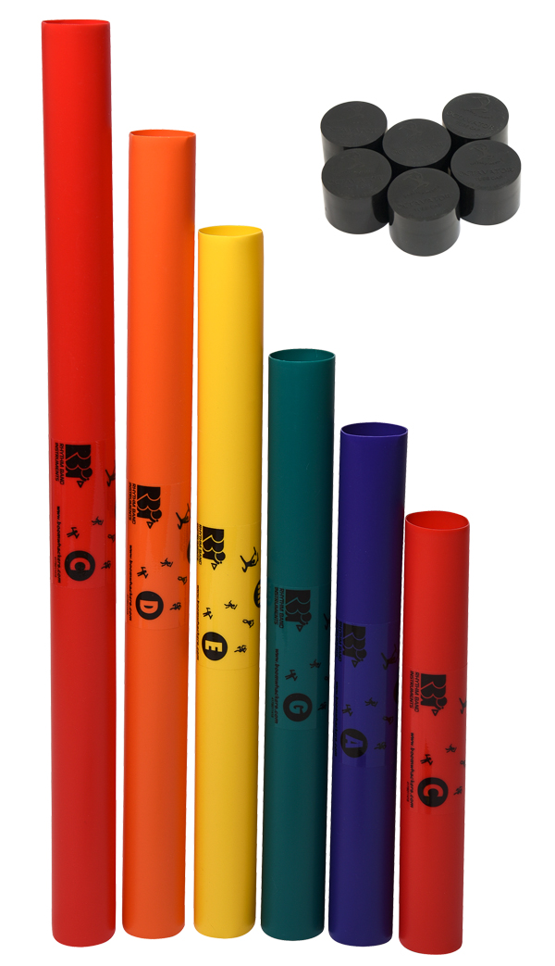

You don’t need to know the difference between a sharp and a flat to produce beautiful music with the new C Major Pentatonic Scale Octavator Set from Boomwhackers.

It’s easy to create melodies and harmonies in both major and minor keys by playing virtually any sequence of the five-note scale provided by these lightweight plastic tubes, whose lengths determine pitch. Struck with mallets or drummed against nearly any surface, they bring to mind a pleasant variation on the sound of marimbas and xylophones.

Would you prefer a lower voice? No problem. Slip an Octavator Tube Cap on one end of a Boomwhacker, and the tube’s inherent tone drops by a full octave, expanding the range of musical possibilities for every user.

Until now, C Major Pentatonic Scale Boomwhackers and Tube Caps were sold separately, but for 2019, the company will bundle the six pentatonic tubes with six Octavators at a single low price.

“Everybody loves Boomwhackers,” says Lane Davy, Executive Vice President of Sales and Marketing at RBi Music, Boomwhackers’ parent company. “They couldn’t be easier to get into, even if you’ve never played an instrument in your life — and now our new prepack widens the choices for corporate event planners, music therapists, and childhood educators.”

The C Major Pentatonic Scale Octavator will debut in booth 6404 at the 2019 Winter NAMM Show.

C Major Pentatonic Scale Octavator = $24.19 Catalog Price, $14.07 Dealer Price

Booth #6404

[rhythmband.com](https://rhythmband.com)