**Contact:** Paul Christian **FOR IMMEDIATE RELEASE**

Big Joe Stompbox Company

**Tel:** 203-338-9668

**Email:** [Paul@BigJoeStompBoxCompany.com](mailto:Paul@BigJoeStompBoxCompany.com)

**JOE STOMP BOX COMPANY Introduces the Power Box Li2, Rechargeable Smart Battery Power Supply for Musicians – Immediately Wins Award**

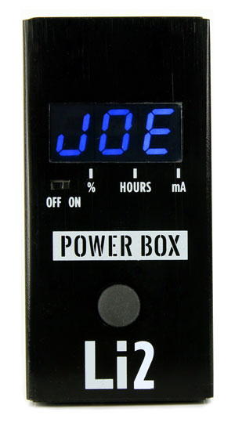

August 12, 2019 – Big Joe Stomp Box Company today announced the release of their new Power Box Li2 rechargeable 9V smart battery power supply for guitar players and musicians. The PB-109 was first shown at the recent Summer NAMM conference where it won an Editors Choice Award from industry trade magazine Music, Inc.

“We’re really pleased with the second generation of this product,” said Paul Christian, co-owner of Big Joe. “Players around the world are already benefitting from clean, long-lasting power running their pedal boards and other equipment. The Li2 improves the power and performance of the rechargeable that Big Joe pioneered back in 2017. We really believe it will be a huge success in the MI world.”

The new Power Box Li2 is a portable, small footprint, rechargeable lithium battery-based power supply capable of powering multiple pedals, pedal boards and high current draw guitar effects for hours. Innovative “smart battery” technology provides visual indication of current draw, battery charge status and battery time remaining. These features let you know exact battery time remaining under current pedal load so you never have to worry that your 9v battery will die in the middle of a gig or session. It is also the perfect solution for eliminating noise, hum and interference problems that can occur when using AC line-fed power sources.

The compact Power Box Li2 measures 3.25”x 1.625”x 1.25” and can be charged overnight using an included USB-C wall cube. MSRP is $159.95. The Li2, and all other Big Joe products, are distributed through RBI Music in Fort Worth, TX and will be available from music retailers across the country starting in August 2019.

rbimusic.com

bigjoestompbox.com