**Contact:** Jim Rockwell **FOR IMMEDIATE RELEASE**

**Tel:** 201-247-7224

**Email:** marketing@rbimusic.com

**Expert Craftwork Meets Handmade Folk Art in Four New A Tempo Percusión Cajons**

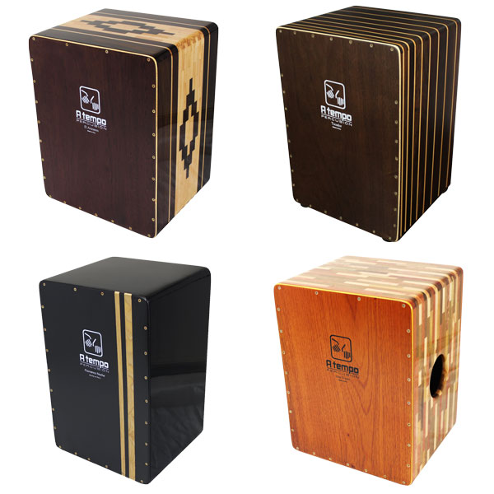Earlier this year the Peruvian craftspeople at A Tempo unveiled a quartet of new cajon models designed for seated play. Each boasts its own distinct sound, design, and aesthetic — although, perhaps even more important than the differences between these new models is the attention to detail and insistence on excellence shared by them all. The company’s four new models include:

• **El Artesano Diamante Snare Cajon**. Made of solid-block Mohena, American Muskwood, and Peruvian Walnut segmented and joined in a “diamond” pattern and finished in a furniture-grade gloss, this cajon contains fixed snares installed internally near the top corners of a thin adjustable tapa playing surface made of multiple plies of Spanish Cedar and Lupuna. Includes padded gig bag.

• **Dos Voces Special Edition**. With a pair of tapa playing surfaces on opposing sides of the shell, the player commands an aggressive flamenco snare sound on one side and a mellower, rounded Peruvian tone on the other. The 100-percent solid wood shell is dressed up with the company’s dazzling segment technique, employing lap joints to create panels of intricate, staggered designs fabricated from solid blocks of Peruvian Walnut and American Muskwood. The panels are then assembled with sturdy dovetail joints. Includes padded gig bag.

• **Noche Flamenco**. Built of solid, furniture-grade panels of Mohena, and fronted by an adjustable tapa assembled from three thin, laminated layers of Spanish Cedar, the Noche Flamenco is finished with an application of polyester-based clear coat hand-rubbed to a shimmering gloss. Its tapa is fitted with two sets of fixed snares mounted diagonally across all four top and bottom corners, leaving the middle of the tapa open for clean bass sounds. Includes padded gig bag.

• **Tocador Cajon, Rayado/Striped**. Featuring a Tropical Walnut and Monterey Pine shell inlayed with blond pinstripes that span the chocolate-brown body, this cajon marries an oversized body typical of Peruvian design with the Spanish influence of internal APTS snare wires set in a top-to-bottom “W” configuration. The cajon is completed with an adjustable tapa made of multi-ply Spanish Cedar. Includes padded gig bag.

A Tempo’s new cajons are distributed in the U.S. by RBImusic.

**El Artesano** **Diamante Snare Cajon** (CJ-PCAJ2-01) = $384 (MSRP)/$269 (MAP)

**Dos Voces Special Edition** (CJ-DOSV-20) = $399 (MSRP)/$279 (MAP)

**Noche Flamenco** (CJ-NOCHE-01) = $356 (MSRP)/$249 (MAP)

**Tocador Cajon, Rayado/Striped** (CJ-TRAY-01) = $384 (MSRP)/$269 (MAP)