**Contact:** Jim Rockwell **FOR IMMEDIATE RELEASE**

**Tel:** 201-247-7224

**Email:** marketing@rbimusic.com

**Take the Celebration to the Streets with the Cajon Carnaval from A Tempo Percusión**

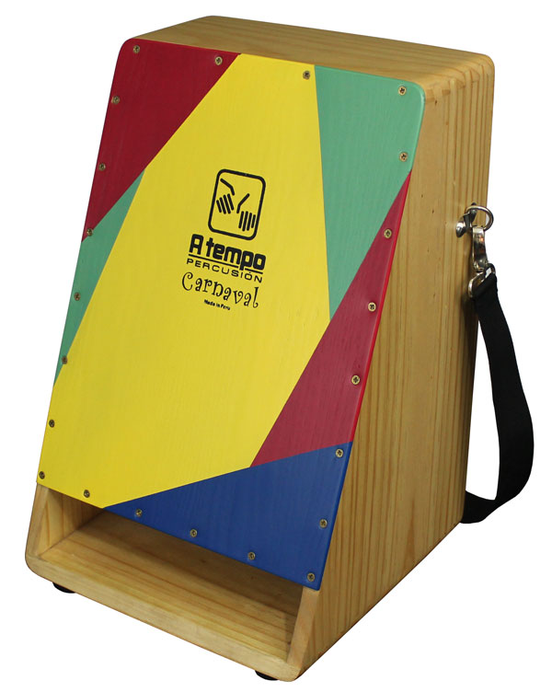An innovative design that upends the traditional seated method of cajon play, A Tempo’s new Cajon Carnaval rearranges the essential elements of the popular cubical drum to enable every cajon enthusiast to play while standing, dancing, or marching in a Mardi Gras parade.

The design team at A Tempo’s Peruvian workshop began by reimagining the basic contours of the typically squared-off cajon shell. First, they downsized the proportions to lighten the load, then tilted the tapa playing surface by 15 degrees to enable unrestricted two-handed drumming from an upright position.

Due to its reduced size, the Cajon Carnaval’s voice is inherently bright, which — when combined with its internal adjustable snare wires — makes it ideal for cutting through any drum circle or percussion troupe. To boost low-end tones and enhance projection, A Tempo increased the proportionate size of the rectangular sound port and moved it to span the bottom of the tapa, well out of reach of the playing area. The result is a delicious array of massive slaps and beefy bass notes that will enliven even the funkiest groove.

Made of stained and satin-finished Monterey Pine, the Cajon Carnaval is graced by a bright four-color tapa that, company founder Alexis Castañeda explains, “was influenced by the clothes of dancers of a Peruvian dance called Son de los Diablos.” The instrument is assembled with tight dovetail joints, which limit the use of screws only to the adjustable tapa and the eyebolts that secure the supplied polypropylene waist strap to the shell. And for those moments when a drummer prefers not to stand, the Carnaval is fitted with four durable rubber feet for stable seated performance.

A Tempo’s Cajon Carnaval is distributed in the U.S. by RBImusic and comes with a free gig bag for worry-free storage and transport.

**A Tempo Cajon Carnaval** (CJ-CARN-01)

18" (height) x 12" (length) x 4-3/4" (top width) x 9-1/2" (bottom width)

$329 Retail/MSRP, $229 MAP/Street

rbimusic.com