**Contact:** Amanda Six **FOR IMMEDIATE RELEASE**

RBI Music

**Tel:** 817-335-2561

**Email:** [asix@rhythmband.com](mailto:asix@rhythmband.com)

**Toca Freestyle II Nesting Djembes and Tom Toms - Drums Nest Snuggly for Transport and Storage**

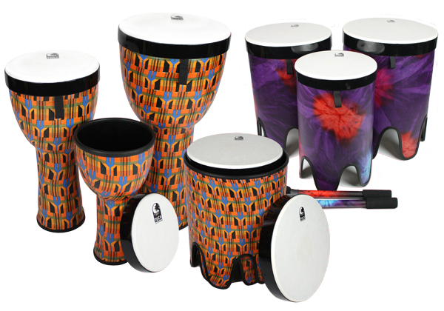**Toca Freestyle II Nesting Djembes** are unique, PVC drums similar to our freestyle djembes but build upon the winning formula embodied in the original series by adding value. The most noticeable difference is the drum heads - which are made from reinforced composite synthetic material for added durability, can be removed and be played like a frame drum! If you purchase the set, you're looking at three Freestyle II djembes in one light package—*and* three frame drums!

The removal of the head also makes them instantly stackable - simply sitting inside of each other for ease of load, transport, and durability.

Available in three head sizes: 8”, 10”, or 12”, these drums are lightweight, always tuned, cleanable, stackable, space saving, weather-resistant and maintenance free. Need to clean them? Wipe them with a cloth or use a gentle cleanser and you're back in business. “Due to these features,” noted Lane Davy, Marketing EVP for RBI, “ we see them being perfect for drum gatherings, classroom, education and therapy!”

**Freestyle II Nesting Tom Toms** take up where the djembes left off. Available in 12”, 14”, and 16” head diameters, they will yield startling bass tones. Available in the same two finishes as the djembes, each Nesting Tom Tom comes with a pair of matching mallets - a smart touch.

The Nesting Tom Toms are fitted with the same high-grade, pre-tuned synthetic heads that pop off instantly. Imagine the tone of the 16” frame drum. Thunderous!

Both the Tom Toms and Djembes are available in two finishes: Kente and Woodstock Purple.

[tocapercussion.com](http://www.tocapercussion.com)