**Contact:** Amanda Six **FOR IMMEDIATE RELEASE**

RBI Music

**Tel:** 817-335-2561

**Email:** [asix@rhythmband.com](mailto:asix@rhythmband.com)

**Toca Updates Beloved Lightweight Djembes With New Head Technology and Enhanced Colors!**

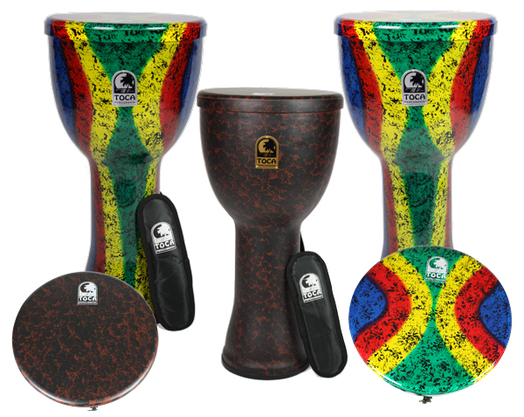These djembes may be called “Lightweight” but don’t let the name fool you. That only refers to the actual weight the drums. When it comes to sonic performance, powerful projection, and genuine value, these drums are definitely in the heavyweight category. Since their successful introduction the Lightweight Djembes featured a patented hybrid design that combines elements of a doumbek with those of a djembe. The sculpted shell is made of an ultra-light synthetic material that dramatically reduces the weight of the drum without sacrificing tone, resonance, or durability. A rubber edge protects the bottom of the shell. Available in 9”, 10” and 12” sizes, each Lightweight Djembe is topped with a permanently attached pre-stretched synthetic head.

For 2018 Toca is introducing a new & improved laminated synthetic head – it is thicker, tougher and much more durable. It also holds the pitch better and, while not a big problem before, the stonger head head vitually eliminates breakage under normal usage. The new head provides great playing response and a wide frequency range while eliminating tuning hassles and concerns about the head losing tension. In combination with the ultra-light shell, this durable head helps each Lightweight djembe to produce clean open tones, crisp slaps, and rich, deep bass tones. The unprecedented portability and sound quality of these djembes make them excellent choices for drum facilitators and music teachers. Professional hand drummers will appreciate their potential as soloing instruments, and players of all levels will appreciate the updated hand-painted finishes. The Jamaican-inspired Rasta are brighter than previous models and have more colors with a blue, red, yellow and green striped motif and a consistent black pattern throughout. The African-themed Earth Tone offers a refined organic black and brown pattern. The fact that the finish covers both the shell and the head adds to the visual uniqueness of these innovative drums.

[tocapercussion.com](http://www.tocapercussion.com)