**Contact:** Amanda Six **FOR IMMEDIATE RELEASE**

RBI Music

**Tel:** 817-335-2561

**Email:** [asix@rhythmband.com](mailto:asix@rhythmband.com)

**Toca Bass Reflex Cajons *-* Broadening dynamic range using proven speaker/cabinet technology**

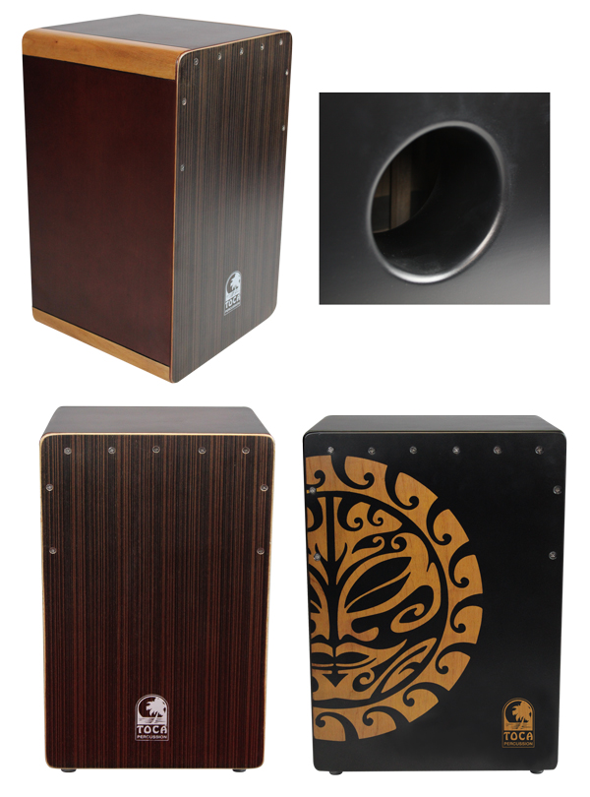Building on their current success with traditional instruments, the Toca design team has taken the next leap in cajon innovation: the Toca Bass Reflex Cajons

“The problem isn’t producing those deep bass tones. To one degree or another, they’re in just about any well-made cajon,” states Lane Davy, RBI’s Marketing EVP. “The problem we had to solve was how to project those tones.” Toca's obsession led them to a surprising rediscovery as near as the living room. The stereo system! Specifically those speaker cabinets invoking bass reflex technology, which magnifies low frequencies and ramps up levels across the board as much as 3dB.

Bass reflex systems only deliver the goods when cabinets are ported properly. The same is true when porting a cajon. The percussionist is analogous to the speaker/driver. Depending on the velocity and type of stroke, the percussionist sets air moving, which combines with the tuning of both cabinet and port to enhance efficiency in projecting lower frequencies. Unlike a simple hole, the bass reflex tuned port works by reshaping air flow relative to lower frequencies, thus enhancing sustain. The Toca variation on the concept is so unique it has been granted a patent.

The flagship of the new series is the **Toca Extended Range Cajon**. The dimensions exceed those of standard cajons, inherently deepening the bass and expanding projection. Thus, it works hand-in-hand with the bass reflex system to promote smoking bass tones while offering a broad dynamic range. It is fitted with dual 8-strand flamenco-style adjustable snare beds and an eye catching tiger mask graphic.

The **Flamenco Cajon – Mahogany** represents the marriage of the folkloric Peruvian and Spanish traditions. The rich sheen of the cabinet and the provision of fixed-snare response embody simplicity and elegance. Fitted with snare-drum-style snare wires, the Toca Flamenco Cajon offers exceptional sensitivity and a shimmering high end.

The C**orner Accent Cajon** reflects the finesse of the joiner. The seamless join of the blonde and walnut panels offers a fine example of the heritage craft. This cajon is beautifully detailed right down to the adjustable Flamenco snares.

The **Workhorse Cajon** lives up to its name by delivering a surprisingly affordable instruemnt with a full tonal palette. The cabinet is made from highly durable MDF, an engineered wood product. Thanks to its density, MDF produces a rigid cabinet with excellent projection. It will hold its shape despite quick shifts in temperature and humidity and will suffer trauma gladly, making it the perfect drum for the road. Available in a choice of walnut or mahogany stain, it’s look belies its modest price.

[tocapercussion.com](http://www.tocapercussion.com)