**Contact:** Amanda Six **FOR IMMEDIATE RELEASE**

RBI Music

**Tel:** 817-335-2561 x108

**Email:** [amanda.six@rhythmband.com](mailto:amanda.six@rhythmband.com)

**Toca Makes Percussionists Lives Easier with New Percussion Tray and Lightweight Stand!**

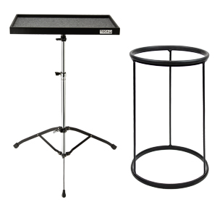When you look at the stage during a concert there is a definite hierarchy of interest. As it should be, the musicians take the limelight. Next it’s the instruments, glimmering and shining, their brilliant finishes and sparkles reflecting cool colors about the venue. Perhaps, if you are a gearhead, the amps and microphones will draw you in for a moment. Last on the list comes the hardware. The audience is not even aware but the musicians and technicians know the show would never go on without stands and trays and clamps! It is with those musicians in mind that Toca has introduced a new Percussion Tray and Lightweight Percussion Stand.

Today’s drummers and percussionists are not expected, nor happy, to be just a beat keeper. They want and need to add extra elements to the mix, and bring in such sounds as maracas, cowbells, tambourines, rattlers, triangles and more. However, you can’t always clamp these items to the kit or the side of a conga. And leaving them on the floor until you are ready to play can be a recipe for disaster - for the drummer, the song and for that maraca that just rolled away! The Toca Percussion Tray is great for holding multiple percussion accessories such as shakers, cowbells, tambourines and even bongos! It includes a fully adjustable stand with double braced legs and is perfect for any drum set player or percussionist.

Generally speaking, the drummer and percussionist have the biggest and most complex instrument set up in any band. Multiple drums, stands, cymbals, clamps and foot pedals make for many heavy trips to and from the equipment truck. Toca’s new Lightweight Percussion Stand helps alleviate some of the drudgery without compromising on sturdiness. Made of solid, black powder-coated steel, this stand holds djembes and doumbeks. It is 12" in diameter, weighs just 2.5 pounds, and a cushioned rubber top ring prevents shell damage while a rubberized bottom ring prevents slippage.

[tocapercussion.com](http://www.tocapercussion.com)