**Contact:** Amanda Six **FOR IMMEDIATE RELEASE**

RBI Music

**Tel:** 817-335-2561

**Email:** [asix@rhythmband.com](mailto:asix@rhythmband.com)

**Long Time Rock and Country Touring and Session Drummer Sean Paddock Joins the Toca Artist Roster**

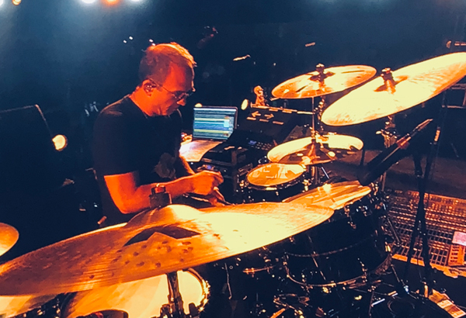Playing on tour with Kenney Chesney for the past 22 years has given Sean Paddock a special perspective on the music industry. He knows what it takes to keep a good gig and be in demand. “Your playing has to be on point and your gear has to not only sound great, but stand up to the rigors of the road,” he says. While he just signed with Toca as an official endorser, Sean has been using Toca percussion in his rig for the past 20 years. “Their products sound phenomenal, and really fit into my style of playing. I use the aluminum shakers on stage as it fits with the acoustic live setting, and I have a set of congas to give some latin flair when working in the studio.” So, when the opportunity came to join the Toca artist roster, he jumped at it.

Sean Paddock grew up in Watertown, NY,  and started playing the drums at the age of four. Within a year he was sitting in, performing live with his musician parents at local nightclubs. When Sean was 9-years-old, he began formal drum lessons and participated in the school band program. After moving to Arizona with his family, it was during his high school years that he started his music career as a semi-pro, playing paid gigs with his father. After high school, Sean was working as a full-time musician, playing the local music seen both in Phoenix and northern New York.

However, he caught his break in 1996 when he traveled to Nashville to check out the music scene. A friend let him know that Kenny Chesney needed a drummer. He auditioned and landed the gig which he's been playing ever since.

When not recording or touring with Kenney, Sean has has not been idle, playing with such rock and country icons as Vince Gill, Sammy Hagar, John Mellencamp, Steve Miller, George Strait, amomg others. His televised appearances include The Grammy’s, Austin City Limits, Sound Stage, the ACM, CMA, AMA award shows, The Tonight Show with Jay Leno, Late Night with Conan O’Brien, The Late Show with Letterman, Good Morning America, and the Today Show. Sean can also be seen in many of Kenny Chesney’s music videos, as well as the Summer In 3D Movie.

Toca is proud to have Sean Paddock as the newest member of its artist roster.

[tocapercussion.com](http://www.tocapercussion.com)