**Contact:** Jim Rockwell **FOR IMMEDIATE RELEASE**

RBI Music

**Tel:** 817-335-2561

**Email:** [jim@filamentsolutions.com](mailto:ldavy@rbimusic.com)

**RBimusic scores another ‘Best in Show’ award at Summer NAMM with Vintage Guitars and Toca Percussion.**

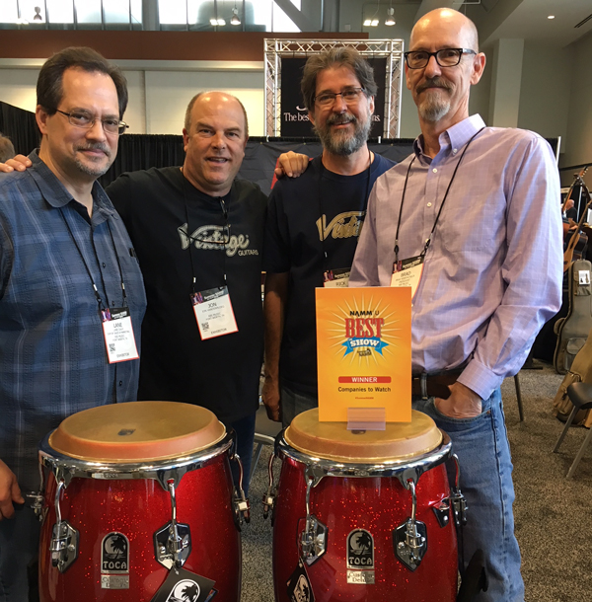



**RBimusic** have received their third 'Best in Show' win at the NAMM Show in four years for Vintage guitars and Toca Percussion with the prestigious **‘Companies to Watch’** Award.

Based in Fort Worth Texas, RBimusichave made a massive impact in the US since taking on distribution of JHS’ **Fret-King** and **Vintage** guitar ranges and their recent purchase of the Toca Percussion line, not only by getting the products stocked in by switched-on dealers across the country, but also by engaging successfully with the press and media and by bringing on board many endorsers, both high profile and grass roots.

**Todd Johnson**, **Manager** at **Groth Music in Bloomington, MN**, who picked RBImusic for the win said the company is “now getting into Toca Percussion and Vintage guitars. They’re starting to branch out and come out of their comfort zone. If you haven’t been carrying their products, reach out to RBI out of Fort Worth, Texas.” **Rick Taylor, Product Manager and Artist Relations** for RBimusic added his profound “thanks to everyone at JHS and RBI for making this possible. Well-done guys. Proud to be a part of the team.” Executive Vice President of Sales and Marketing, Lane Davy added that “the acquisition of Toca in 2017 has been an absolute boon for RBimusic. We’re really excited to be able to breathe new life into such an iconic brand!”

Picture shows (l-r) Lane Davy, Jon Vanderploeg, M&A Investor Relations, Rick Taylor, and President and CEO, Brad Kirkpatrick, with the new **Toca Custom Deluxe Congas** in the **Red Sparkle** finish.

Vintage Guitars US - RBimusic [vintageguitarsus.com](http://vintageguitarsus.com) [sales@fretking-vintage.com](mailto:sales@fretking-vintage.com) 800-424-4724

Distributed worldwide by John Hornby Skewes & Co. Ltd. [www.jhs.co.uk](http://www.jhs.co.uk)/brands/vintage

Toca Percussion – <tocapercussion.com> [sales@rbimusic.com](mailto:sales@rbimusic.com) 800-424-4724