**Contact:** Amanda Six **FOR IMMEDIATE RELEASE**

RBI Music

**Tel:** 817-335-2561 x108

**Email:** [amanda.six@rhythmband.com](mailto:amanda.six@rhythmband.com)

**Boomwhackers® Introduces Two New Sets That are Perfect for Classroom Learning!**

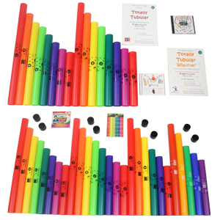Boomwhackers Tuned Percussion Tubes are wonderful and unique instruments that bring the joy of music to hundreds of thousands people. They are one of the most popular instruments in music education and music therapy around the world! Durable and easy to grip, there is no limit to their uses or fun! They also come in many different set arrangements that cater to specific types and sizes of groups.

The first new addition to those sets is the **Boomwhackers 16 Tube Activity Pack** which allows you to gamify your Boomwhackers!This set is great for smaller groups and has activities you can start right out of the box. It includes 2 sets of the basic C major Diatonic set along with 2 CDs featuring games and 2 books with CD sets featuring activities that can be done indoor or outdoors and feature movement. It’s great for libraries, day camps, schools or wellness activities.

The second new set is the **Boomwhackers** **Classroom Activity Pack** and it has everything a teacher or group facilitator could need to get started with Boomwhackers. Good for up to 25 players and a facilitator. Includes a free DVD – Play Boomwhackers that features Boomwhackers Beatz – colorful, bouncing Beatz that let kids know when to play. This set also includes 2 sets of the basic C major Diatonic set, a set of 5 Chromatic notes, a C major Pentatonic set, 8 Octavator Caps which lower the pitch of a tube by an octave when placed on one end of the tube, and a pack of Chroma-Notes Stick Ons.

Each set ships in a single brown box with a label detailing the contents.

[tocapercussion.com](http://www.tocapercussion.com)