**Contact:** Amanda Six **FOR IMMEDIATE RELEASE**

RBI Music

**Tel:** 817-335-2561 x108

**Email:** [amanda.six@rhythmband.com](mailto:amanda.six@rhythmband.com)

**Toca Jr. Cajons Perfect As Child’s First Percussion Instrument and Music Education Market!**

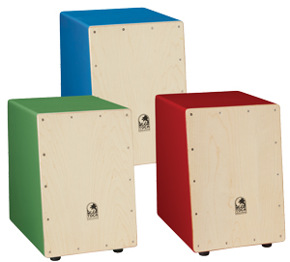Beating two sticks together, shaking a tambourine or even tapping on a drum are excellent ways to introduce the concept of rhythm to children. However, the next step after that is critical to growth and keeping up that initial interest in music. The cajon has been around for hundreds of years and while it can take years to fully master all the ins and outs, it is also one of the easiest instruments to get started with. It’s very easy to create sounds, and the sounds generated are exciting to hear – a big boom, a snappy mid-tone and that cracking slap sound! It would seem to be the logical choice, however a full sized cajon can be too much for smaller frames and small hands to play without trouble. It is with this thought in mind that Toca has introduced their Jr. Cajons.

The Maple tapa, or playing surface, is slanted for easy playing. The body features bright colors that “pop” in the classroom. It measures in at 13 - 3⁄4” tall, which is considered to be the perfect size for early childhood learning. Further benefits of having cajons in the class are the ability to teach improvisational skills, playing together in small and large groups, and discovering and participating in music from around the world.

[tocapercussion.com](http://www.tocapercussion.com)