**Contact:** Amanda Six **FOR IMMEDIATE RELEASE**

RBI Music

**Tel:** 817-335-2561 x108

**Email:** [amanda.six@rhythmband.com](mailto:amanda.six@rhythmband.com)

**Toca Introduces World Percussion Jamal Drum Series!**

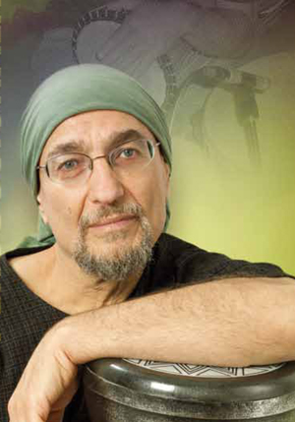Toca Percussion has announced the release of the new World Percussion Jamal Drum Series. Designed in collaboration with doumbek Master Jamal Mohamed, The New Jamal Drum Series features Mazhar Drums, a Riq, and three new Frame Drums. Each of these drums are adorned with Jamal’s signature logo and constructed of durable, lightweight PVC with a Dark Red painted finish.

One of the most popular and ubiquitous world percussion instruments, the frame drum is commonly defined by the fact that the drumhead’s width is greater than the depth of the frame. Jamal’s frame drums also include a tunable system and come in 10”, 12” and 14” sizes that are sold individually or as a set of three.

Perhaps unfamiliar to many, the Riq is a traditional, Middle-Eastern instrument similar to a tambourine and used as a traditional instrument in Arabic music. It is an important instrument in both folk and classical music throughout the Arabic culture. It traditionally has a round frame, jingles, and a thin, translucent head. The Jamal Riq comes with 5 sets of dimpled jingles and a 10” durable, synthetic head that produces a time-honored, classic sound.

The Mazhar is a large, heavy tambourine, again traditionally used in Arabic music. Its single head is considerably thicker than that of its smaller cousin, the Riq, The Jamal Series Mazar has a 12” head and is available with or without dimpled brass jingles.

Born in Lebanon and raised in Chicago, Jamal Mohamed takes advantage of his wide cultural experiences, transporting them into diverse musical experiences which include live and studio work with Sting, Mark O'Connor and Giovanni Hidalgo. These are but a few of his credits, augmenting a long list of recordings for film and television documentaries and specials. In addition, Jamal is a widely acclaimed educator and clinician whose work has carried him literally across the globe: numerous percussion appearances in Bali and Jakarta festivals, opera soloist spots in Hong Kong and Beijing, and a variety of rhythmic roles from Yukon to Mexico City.

[tocapercussion.com](http://www.tocapercussion.com)

