**Contact:** Amanda Six **FOR IMMEDIATE RELEASE**

RBI Music

**Tel:** 817-335-2561

**Email:** [asix@rhythmband.com](mailto:asix@rhythmband.com)

**Toca Signs “Little Steven And The Disciples of Soul” Percussionist, Anthony Almonte, to Artist Roster!**

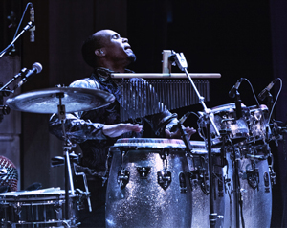Currently on tour with “Little Steven and the Disciples of Soul” (Steven Van Zandt – of the E. Street Band), and having performed over the past four years with Kid Creole and the Coconuts, Anthony Almonte has signed on with Toca Percussion as an endorsing artist.

Anthony’s work around the New York music scene is well known, having recorded as a percussionist/vocalist for Kid Creole and the Coconuts, Edwin Bonilla y Su Son, and New York-based salsa bands Grupo Arcano and Los Hacheros. Anthony also recorded on Little Steven’s latest single and music video, Merry Christmas (I Don’t Want to Fight Tonight) and the recently released Soulfire Tour 2017 Live Album.

“This tour is going amazing and everyone is in love with the set up,” noted Anthony during a stop on the Little Steven 2018 Soulfire World tour. “Little Steven called them the best sounding congas he’s ever heard!” That’s quite the compliment.

Almonte was born June of 1992 in New York City. As a child, Anthony’s parents placed him in music class at the age of 6, after showing great interest in “bomba” and “plena” rhythms during the holidays in Puerto Rico. Since then, he has studied with music greats such as Angel Ruben Rodriguez, and Charlie Lagond, and he began performing live in New York at the age of 10. Anthony’s energetic performance and stage presence offer a breathtaking experience to audiences.

In addition to his current gig, Almonte has performed with a wide breadth of artists, including Bruce Springsteen, Paul McCartney, Peter Wolf, Paquito D’Rivera, Andy Montanez, and Dave Valentin. At Thalia Spanish Theater, he performed in Cali Salsa Pal Mundo’s sold-out hit “History of Salsa”, as well as AfroTango with world renowned bandoneonist Raul Jaurena.

Toca is excited to have Anthony Almonte as a member of its artist roster.

[tocapercussion.com](http://www.tocapercussion.com)