**Contact:** Lane Davy **FOR IMMEDIATE RELEASE**

RBimusic

**Tel:** 817-335-2561

**Email:** [sales@rbimusic.com](mailto:ldavy@rhythmband.com)

**RBImusic Moves Headquarters to New, Larger, State of the Art Location!**

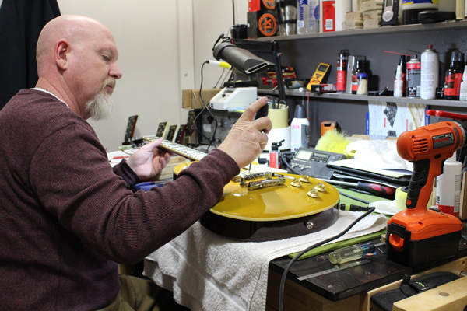With the 2017 acquisition Toca Percussion and the rapid growth of its marquee lines, Vintage Guitars, Odery, A Tempo, Boomwhackers and the continued success of their core distribution business, RBimusic has made the strategic move of relocating their headquarters to a new venue in Fort Worth, TX.

While it’s easy to label this as just simply a move to a larger facility, there is more at play here. This new building is really a team member in aiding RBimusic to meet their growth plans and customer service goals. Both the warehouse and the office areas have doubled in size, which allows for greater inventory and the hiring of more staff. They have integrated the warehouse and office space resulting in greater efficiency and streamlined order processing. The warehouse has specified climate-controlled areas for drums kits and guitars, meaning less weather related product issues and thus happier dealers.

The entire building has been outfitted with hi-speed data ports and wi-fi for speedy, seamless order entry and customer communications. They have also more than doubled the assembly room, making light manufacturing, the kitting of products and custom orders a breeze. In the office there is a dedicated Product Showroom where dealers, artists and even their own employees can try out the gear and learn all the features of every product they ship. On the guitar side RBimusic have built a luthier station where every guitar that enters and exits the building is checked and tuned so every instrument is playable right out of the box!

The old saying of “location, location, location” certainly applies here too! The short proximity from shipping hubs for air, rail and major parcel services like FedEx, UPS and USPS has increased available shipping hours and improved order turn-around times. And if you’re looking to come for a visit, RBimusic is just minutes from DFW International Airport. You can get there from anywhere.

As anyone who has been involved knows, moving a business takes much time, effort, and the cooperation of all of the employees. It’s stressful and, if not done properly, runs the risk of downtime and unhappy customers. So, perhaps the best feature of this new edifice is that there is plenty of room to grow!