**Contact:** Lane Davy **FOR IMMEDIATE RELEASE**

RBimusic

**Tel:** 817-335-2561

**Email:** [sales@rbimusic.com](mailto:sales@rbimusic.com)

**Odery Cafekit Now Available in Stunning Copper Sparkle!**

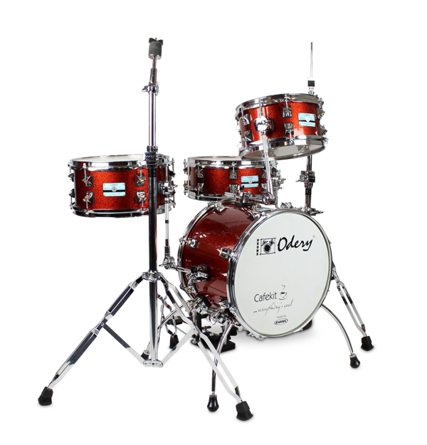Since its introduction, the Odery Cafekit has been a hit amongst players that that want a compact kit for quick gigs in smaller venues, and even for those who play a more stripped down kit in larger venues. It’s certainly convenient to carry, a breeze to set up, and best of all, it sounds amazing! It’s made of 100% basswood, with elegantly practical new quick-rlease lugs, and ergonomic hardware that is easy to handle.

But what makes this set so unique is that, unlike other small kit offerings, the Odery Cafekit can expand, enabling it to become a “regular” kit in the future, which significantly increases the versatility, usefulness and life of the instrument.

Adding to the immensely popular Black Ash, Blue Sparkle and White Ash finishes, this year Odery is introducing a stunning Copper Sparkle color way that is sure to make a splash on stage! All Cafekit models come with a pedal, hi-hat stand, cymbal stand, 2 tom holders, 4 bass spurs, a pedal adaptor, and a clamp-holder for the floating snare. All at a street price of about $400.00! Additionally, you can also purchase the Odery Expansion Pack, which provides more opportunities to customize your set up.

Odery Drums has been making hand made drum kits for more than 25 years and is generating more buzz each year with its ever expanding line and outstanding reputation as a builder of quality kits. They are made in an eco-friendly, sustainable factory, and have been garnering awards and best-in-class reviews from magazines throughout the world.