**Contact:** Amanda Six **FOR IMMEDIATE RELEASE**

RBimusic

**Tel:** 817-335-2561

**Email:** asix@rhythmband.com

**A Tempo Rolls Out Stunning New Jaspé Dos Tonos Line of Cajons, Congas and Bongos! Introduces New Standard in Snare Cajon Tuning!**

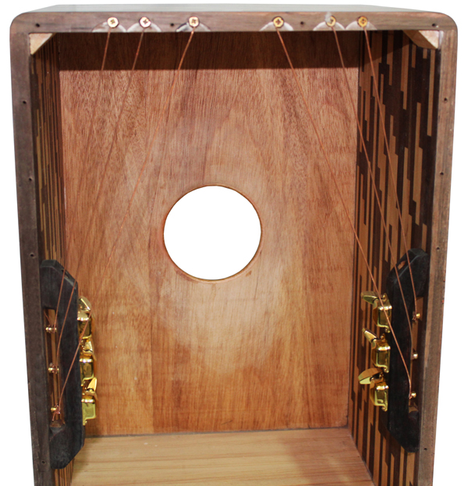The New Jaspé Dos Tonos Cajon is constructed with a combination of two beautiful woods: Peruvian Walnut and Monterery Pine, in a stunning mosaic-jasper inlay pattern with a gloss finish. The proprietary tapa produces deep bass tones and crisp highs. It also features the unparalleled “APTS” A Tempo Precision Tuning System, which allows you to fine tune the tension on each of the 6 individual snare wires with the use of six tuning pegs. This innovative tuning system is unique to A Tempo and is sure to thrill cajon players the world over.

The new Jaspé Dos Tonos Congas 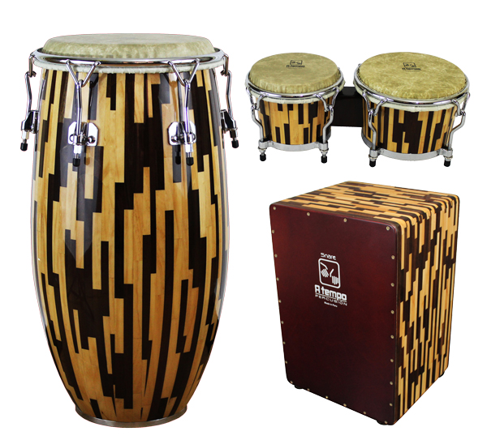 are also handcrafted from Peruvian Walnut and Monterey Pine and are constructed with staves, formed from individually cut, solid blocks of wood, and assembled into a striking Mosaic-Jasper pattern. Staves are used to create drums with smooth, round curves. Designed with a lower, slightly bigger belly, these drums have a captivating sound and look. Smooth lines and extra air volume create a prized combination of warmth and projection. The sound is also enhanced by durable, low-contact hardware, including minimalist lugs, which open up the sound of both the head and shell while keeping weight to a minimum. Finished with Remo Tucked Fiberskyn heads, these drums are top of the line in every way. Available in three sizes: 11” Quinto, 11 3/4” Conga, and 12 1/2” Tumba.

The Jaspé Dos Tonos Bongos utilize the same woods and stave construction as the congas and as such create drums that are both visually and audibly striking. The sound is further enhanced by durable, low-contact hardware - which opens up the sound of the head while keeping weight to a minimum. Finished with Remo® Tucked Fiberskyn® heads, these drums were designed with the professional musician in mind.

CG-JASP-QU (11” QuInto)

CG-JASP-CO (11 3/4” Conga)

CG-JASP-TU (12 1/2” Tumba)

BG-JASP-01 (Bongos)

CJ-JASP-01 (Cajon)