**Contact:** Amanda Six **FOR IMMEDIATE RELEASE**

RBI Music

**Tel:** 817-335-2561 x108

**Email:** [amanda.six@rhythmband.com](mailto:amanda.six@rhythmband.com)

**Rikki Rockett and Troy Luccketta Sign with Toca Percussion!**

Toca Percussion is pleased to announce the signing of two of the most iconic drummers in rock history as endorsers.

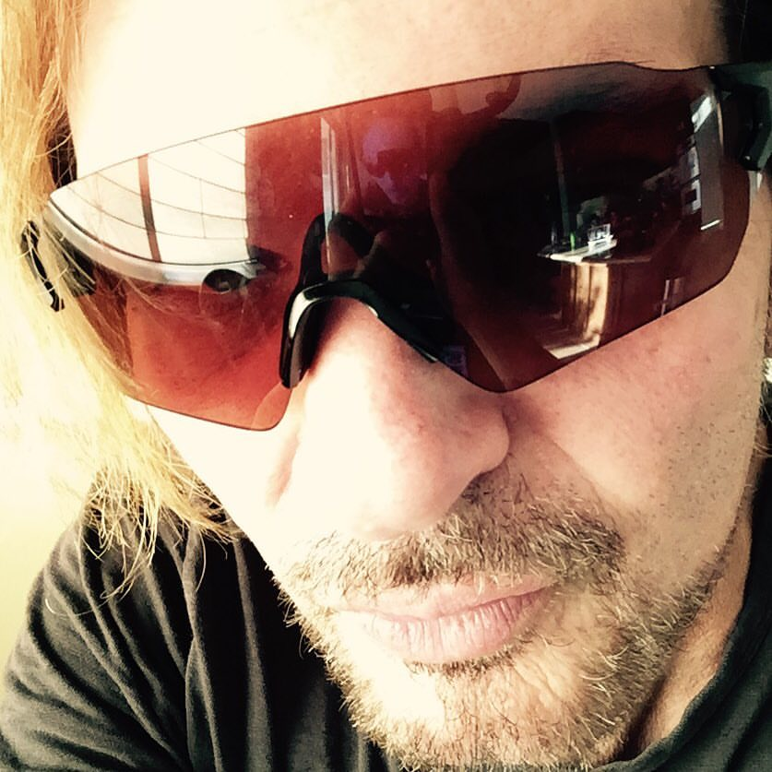

Rikki Rockett co-founded and is the drummer for Poison. The band has sold over 45 million records worldwide and has sold 15 million records in the United States alone. The band charted ten singles to the Top 40 of the *Billboard* Hot 100, including six Top 10 singles and the Hot 100 number-one, "Every Rose Has Its Thorn".

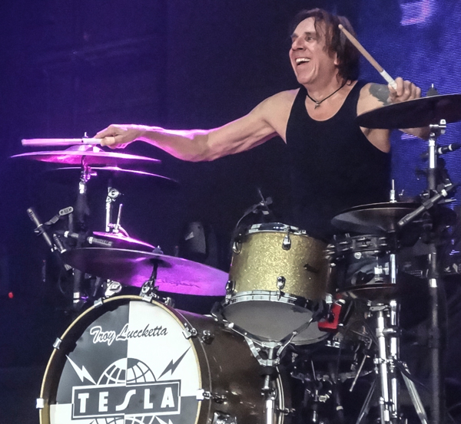Troy Luccketta is the drummer for the metal band Tesla and started playing drums at 10 years old. He has a wide variety of musical tastes including Latin style percussion. In 1984 Troy joined Tesla. They have released seven studio albums and have sold over 14 million albums in the U.S. alone.

“Having two artists with the breadth of talent and styles that Rikki and Troy possess joining the Toca roster speaks volumes about the influence of this brand,” says Executive Vice President of Sales and Marketing, Lane Davy. “We here are committed to expanding Toca’s reach around the world with instruments and artists. This brand is on the way up!”

[tocapercussion.com](http://www.tocapercussion.com)