**Contact:** Amanda Six **FOR IMMEDIATE RELEASE**

RBI Music

**Tel:** 817-335-2561 x108

**Email:** [amanda.six@rhythmband.com](mailto:amanda.six@rhythmband.com)

**Toca Releases New Eric Velez Signature Series Professional Congas, Bongos and Timbales!**

****Toca Percussion has announced the release of a new line of Eric Velez Signature Series pro quality congas, bongos and timbales adorned with a stunning Gun Metal Glitter finish. The congas are Cuban style with 3 metal rings, finished in Black Mirror chrome and have rubber bottoms. They stand at 28” tall. The accompanying bongos feature the same finishes outfitted on 7” and 9” heads and Easy Play hoops. Both the congas and bongos are made with sustainable plantation grown Asian oak wood. As for the timbales, one can just imagine the spectacle when the stage lights are shone on these drums! That special glitter and the Black Mirror chrome reflecting off will be a sight to see! The timbales feature 14” and 15” heads and come fitted with synthetic heads, a heavy-duty adjustable stand and an adjustable cowbell mounting bracket.

Eric Velez is a world-renowned percussionist who has been paying with the Marc Anthony band since 2000. He says this new series “has some old school flair mixed with new school technology and design.” Playing Toca products for decades, Marc loves “strong sound that resonates through the audience. The drums are hold up to the rigors of the road and provide crisp, clean and clear notes. For me, Toca is the best percussion company out there.”

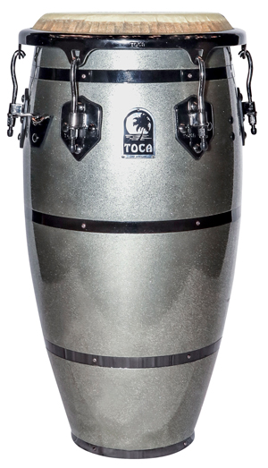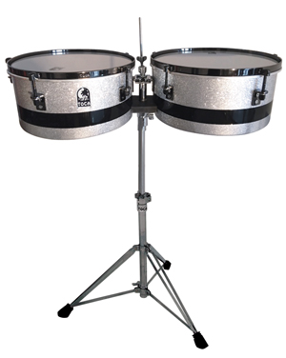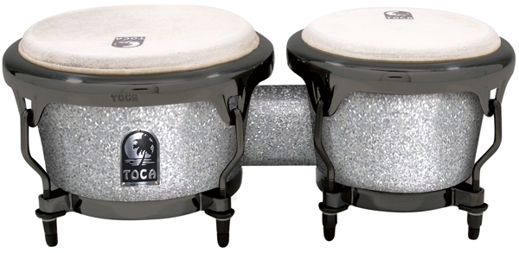

[tocapercussion.com](http://www.tocapercussion.com)