**Contact:** Lane Davy **FOR IMMEDIATE RELEASE**

RBimusic

**Tel:** 817-335-2561 x102

**Email:** [LDavy@rhythmband.com](mailto:ldavy@rhythmband.com)

**Odery Adds Two New Flavors to its Award-Winning Fluence Fusion Line**

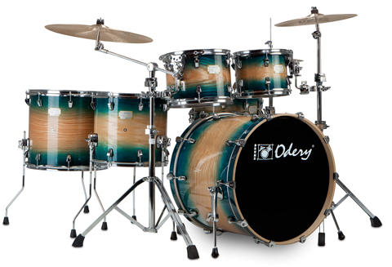Odery Drums has been making hand made drum kits for more than 25 years and is generating more buzz each year with its ever expanding line and outstanding reputation as a builder of quality kits. They are made in an eco-friendly, sustainable factory, and have been garnering awards and best-in-class reviews from magazines throughout the world.

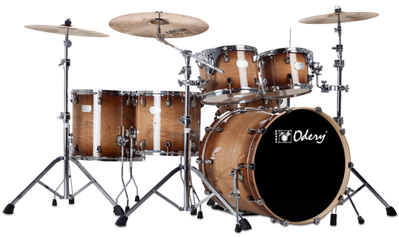Following up on the success of its Fluence Fusion line Odery is adding two new colors, Blue Burst and Magma Vintage. In addition to these classy new looks, these two new sets utilize the same Maple hybrid 6-ply shells with a 7.2mm thickness (external) Maple/Maple/Bass Wood (internal) used in the rest of the line. They come complete with a kick drum, a snare, two rack toms and two floor toms. A hardware pack with a hi-hat stand, snare stand, straight cymbal stand, boom cymbal stand and a single bass pedal is also included.

With a street price of starting around $1100 it’s easy to see why this kit is becoming so popular.