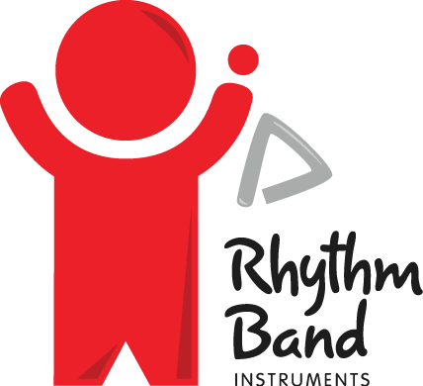

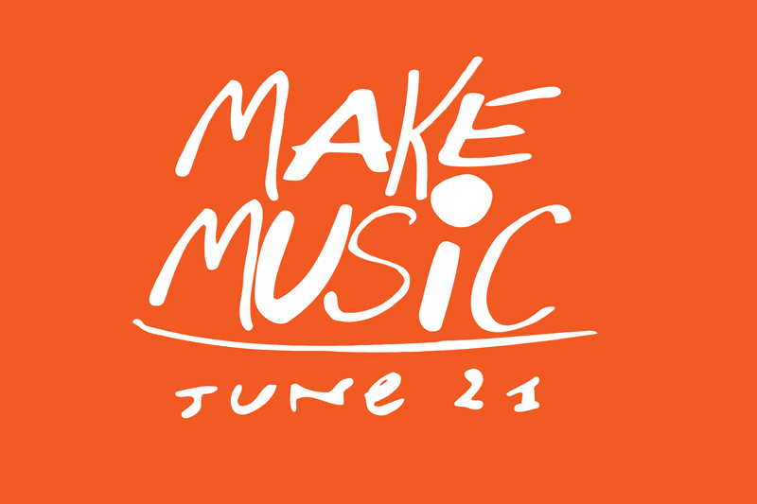

**Contact:** Amanda Six **FOR IMMEDIATE RELEASE**

RBimusic

**Tel:** 817-335-2561 x108

**Email:** [asix@rhythmband.com](mailto:asix@rhythmband.com)

**Rhythm Band Instruments and Make Music Team Up Again for World-Wide Day of Music**

Rhythm Band Instruments partnered with **Make Music Alliance** for Make Music Day again on June 21st, 2017. This is an international day that started in 1982 in France when Jack Lang and his staff at the Ministry of Culture dreamed up an idea for a new kind of musical holiday; a day where free, live music would be everywhere. Since then more than 5 million people in over 120 countries have participated!

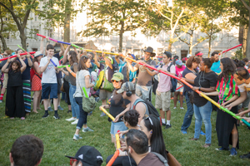RBI donated over 4,000 Boomwhackers® tubes this year to 16 participating locations across the country. In 10 of these locations, the tubes were used with “Mp3 Experiments”, a free participatory audio adventure created by *Improv Everywhere.* Attendees downloaded an app on their smartphone and listen to synchronized instructions. People in the surrounding area who were unaware were surprised with a flash performance and games with Boomwhackers. These colorful, musical tubes can be hit on any hard surface to create a pitched sound. They have been used in schools, at events, and even by professional musicians. Because they are made of a lightweight plastic, they can be played anytime, anywhere!

Rhythm Band Instruments has been a part of music education since 1961, partnering with music educators all over the country to bring rhythm and fun to students at any level or age. RBI is so excited to be partnering again with **Make Music Alliance**. You can visit the **Make Music** website at [www.makemusicday.org/participate/](http://www.makemusicday.org/participate/) to learn more and plan for next year’s event.