**Contact:** Lane Davy **FOR IMMEDIATE RELEASE**

RBimusic

**Tel:** 817-335-2561 x102

**Email:** [LDavy@rhythmband.com](mailto:ldavy@rhythmband.com)

**A Tempo Introduces Performance Cajons – Professional Features Without The Pro Price!**

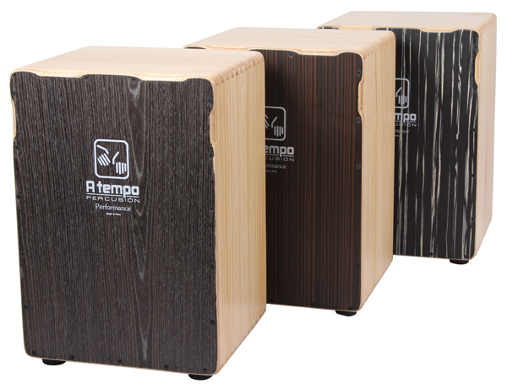

If you’re looking for an upgrade to your starter cajon, it can be a bit frustrating to find a drum with great features at a price that won’t break the bank. Well, look no further than A Tempo’s new Performance line of cajons. Hand made in Peru, the traditional home of cajons, these three new drums come standard with pro attributes at a reasonable price.

Like all their drums, these cajons have solid wood frames, in this case Monterey Pine is the choice, and utilize A Tempo’s signature dovetail joinery and furniture-grade construction to provide superior strength and fit. Another common feature throughout their line is A Tempo’s proprietary Tapa (playing surface) that brings out deeper bass tones and crisper highs than the competition. With heavy-duty rubber feet, a deluxe bag, ergonomic cut-outs for more comfortable playing, and a choice of three different Tapa finishes these drums are a steal at $199(MAP)!

CJ-PERF-01 Black Wood Grain

CJ-PERF-02 Java Stripe

CJ-PERF-03 Black Stripe