**Contact:** Lane Davy **FOR IMMEDIATE RELEASE**

RBimusic

**Tel:** 817-335-2561 x102

**Email:** [LDavy@rhythmband.com](mailto:ldavy@rhythmband.com)

**A Tempo’s New Cascada Cajon Fuses Function, Innovation and Beauty!**

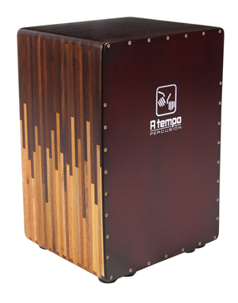A Tempo Percussion, known for its handmade percussion instruments built in Peru, the traditional homeland of cajons, has introduced its new professional level Cascada cajon. Like all A Tempo creations it is made with a solid wood frame. Its stunning good looks are created by the use of a cascading inlay pattern of the hardwoods Tropical Walnut and Mohena joined using A Tempo’s signature dovetail joints and furniture-grade construction providing superior strength and fit. This cajon is topped off with a stunning gloss finish. As with every cajon they make, the Cascada is fronted with A Tempo’s proprietary Tapa (playing surface) that brings out deeper bass tones and crisper highs than the competition.

What makes this drum so special, though, is a new tunable flamenco snare system that allows the tension to be adjusted similar to a snare drum, yielding the best separation between snare and bass of any cajon on the market. Talk about customizing your sound! Free deluxe padded gig bag included!

CJ-CASCA-TS