**Contact:** Lane Davy **FOR IMMEDIATE RELEASE**

RBimusic

**Tel:** 817-335-2561 x102

**Email:** [LDavy@rhythmband.com](mailto:ldavy@rhythmband.com)

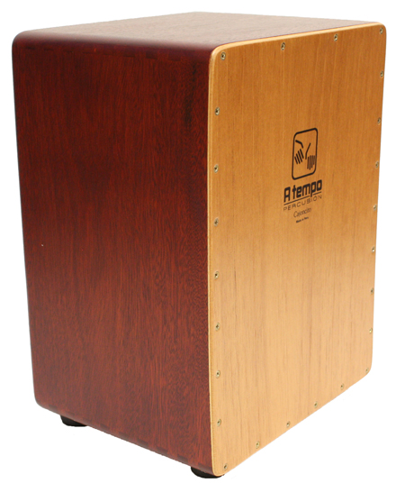**A Tempo Expands Cajoncito Line With Solid Hardwood Version!**

A Tempo has taken the compact convenience of its Cajoncito and upgraded it to include the punchiness of a solid hardwood frame. While this cajon is smaller in size, it’s sound is not.

The Cajoncita Mohena is a scaled-down, Flamenco-style cajon with traditional, guitar wire snares. At about 3/4" the size of A Tempo’s other Peruvian cajons, it’s perfect for a younger or smaller stature player or for traveling. The frame is made from solid Mohena panels with dovetail joints, utilizing furniture-grade construction - just like on A Tempo’s larger instruments. Playing and resonant surfaces are made from the same great sounding, multi-ply Lupuna and Spanish Cedar found on their pro instruments.

CJ-CCITO-20