**Contact:** Lane Davy **FOR IMMEDIATE RELEASE**

RBimusic

**Tel:** 817-335-2561 x102

**Email:** [LDavy@rhythmband.com](mailto:ldavy@rhythmband.com)

**A Tempo Expands Artesano Line With New Bongos!**

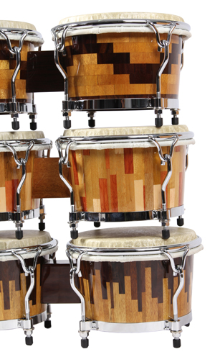

Long a signature creation in the A Tempo line, the Artesano cajons have thrilled percussionists with its craftsmanship and stunning good looks. Now they have expanded both that quality and beauty into a new line of Artesano Bongos! Just like all A Tempo drums, these bongos are hand-made in Peru using the same hardwood inlay technique as the Artesano cajons.

Each drum utilizes a mixture of the sensuous and exotic Mohena, and Tropical Walnut or Requia woods to create the Escalando, Cascada or Natural Woodblock designs. But for an instrument that can be so rough on the hands, strength and beauty are nothing without playability. To that end, each bongo has low contact hardware and Remo Fiberskyn 3 heads that make playing a pleasure, to say nothing of the ease of tuning and durability.

 BG-ARTE-01, Mohena and Tropical Walnut, Escalando Pattern

 BG-ARTE-02, Mohena and Requia, Natural Woodblock Pattern

 BG-ARTE-03, Tropical Walnut and Mohena, Cascada Pattern