**Contact:** Lane Davy **FOR IMMEDIATE RELEASE**

RBimusic

**Tel:** 817-335-2561 x102

**Email:** [LDavy@rhythmband.com](mailto:ldavy@rhythmband.com)

**A Tempo’s New Angular Cajon’s Curvilinear Shape Does the Bending So You Don’t Have To!**

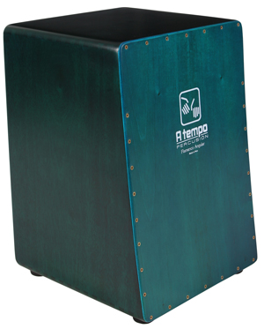A Tempo Percussion adds to its line of handmade cajons built in Peru with the introduction of the Angular Cajon. Like all A Tempo cajons it is made with a solid wood frame, in this case Peruvian hardwood Mohena, and utilizes furniture-grade construction providing superior strength and fit. And, as with every cajon they make, the Angular Cajon is fronted with A Tempo’s proprietary Tapa (playing surface) that brings out deeper bass tones and crisper highs than the competition.

The twist (pun intended) with this cajon is the angled front. By pushing out the bottom, or bass, section it makes the reach to play those notes easier and more natural. No need for a sore back or to tip the cajon backwards eliminating a precarious situation. This cajon also comes fitted with a flamenco style snare wire. And let’s not forget the mesmerizing translucent turquoise finish that is reminiscent of the color of the ocean off the shores of Lima, Peru! Free deluxe padded gig bag included!

CJ-ANGLE-TS