Contact: Jim Rockwell FOR IMMEDIATE RELEASE
RBI Music
Tel: 201-247-7224
Email: jim.rockwell@rbimusic.com

Toca’s New Collapsible Barrel Stand With Premium Locking Casters Raises the Bar Again

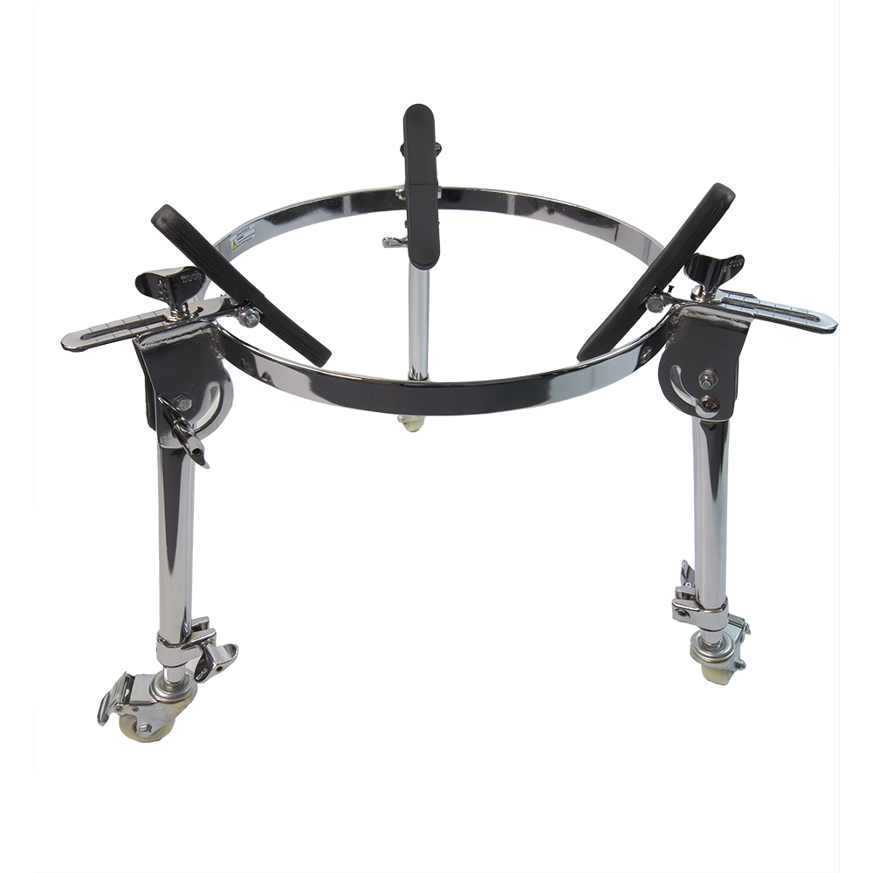
Toca Percussion proudly introduces the latest evolution of their popular Collapsible Conga Barrel Stand, now enhanced with high-end Fully Locking Casters. This upgraded stand takes convenience, mobility, and stability to a new level.

Toca’s newest barrel stand retains the player-focused features of the previous model while adding a major upgrade: a premium caster system that transforms transport and setup for working percussionists.

One of the standout improvements is the addition of Fully Locking Casters featuring non-marking, polyurethane wheels. These high-performance wheels glide smoothly across stage floors, studios, and rehearsal spaces without scuffing or leaving residue. Unlike many competing stands that still rely on old-fashioned butterfly friction locks—which may stop a wheel from moving but allow the hub to keep spinning, and which can loosen under vibration and extended playing—Toca’s Fully Locking brake simultaneously locks both the wheel and the swivel raceway with a single press of the metal pedal. That dual action prevents the slow shifts, unexpected spinning, and eventual rolling that friction models can exhibit during a set, ensuring the stand is always completely stationary. This level of stability is essential for percussionists who demand rock-solid performance from their hardware.

The stand still features its signature advantages: fully height-adjustable legs, rubber grippers, and a lightweight but rugged construction. Crafted from heavy-gauge, chrome-plated steel, it maintains the strength and durability that players rely on while remaining easy to maneuver thanks to the new caster system.

Its fully foldable legs, a dramatic improvement over earlier partial-fold designs, allow for compact storage in gig bags or road cases, making this stand an ideal companion for musicians who travel frequently. Assembly and breakdown remain incredibly fast due to the simplified mechanical design.

Another hallmark feature remains: the drum size demarcation adjustment lines, which allow for quick, precise setup. These lines ensure consistent positioning of the rubber grippers, making it effortless to place any size conga exactly where it needs to be.

tocapercussion.com
rbimusic.com

