Contact: Jim Rockwell FOR IMMEDIATE RELEASE
RBI Music
Tel: 201-247-7224
Email: jim.rockwell@rbimusic.com

Toca Brings 60+ Years of Classroom Heritage to Retail with New "Toca Tykes" Line
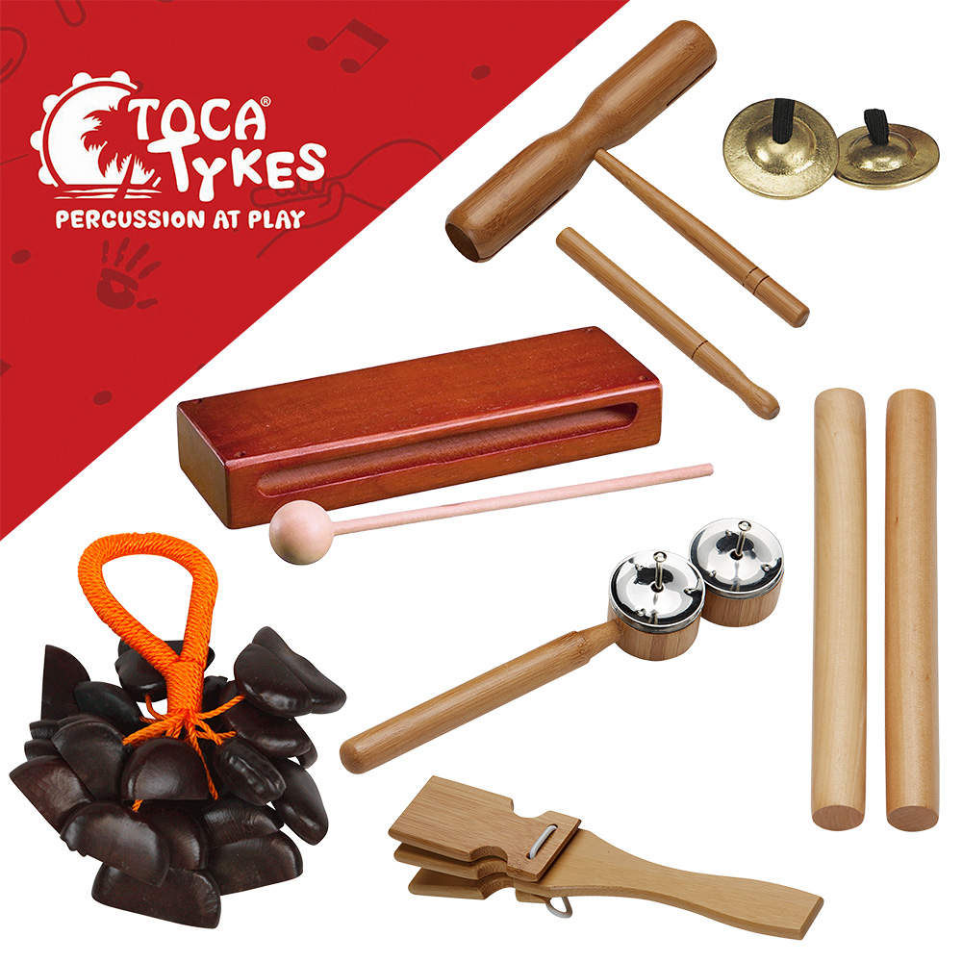
Toca percussion is proud to announce the launch of Toca Tykes, a brand-new collection of educational percussion instruments designed for children ages 3 and up. While the instruments offer the classic sounds and durability that educators have trusted for decades, the line marks a strategic entry into the general dealer and chain market, featuring an all-new premium packaging design optimized for retail display.

Toca Tykes is rooted in a philosophy that music is essential for early childhood development. These are not merely toys; they are curated, high-quality musical tools designed to build musical confidence at an early age. The line focuses on tactile engagement, improving motor skills and rhythm through hands-on experience. Whether used in a classroom setting or the "family band," these instruments are designed to enhance social inclusion, fostering teamwork and communication skills through group play.

With this new line of products, Toca Tykes possesses a unique pedigree. It is backed by its parent company, Rhythm Band Instruments (RBI), which has been the leading provider of percussion products to the education and school market since 1961.

Toca Tykes takes this 60-year legacy of durability and brings it to the retail shelf. The standout feature for dealers is the all-new visual presentation. Every item in the line features beautifully designed, vibrant, color packaging engineered to be easily hung and displayed on planograms, end caps, slat walls, and grid walls to maximize visibility and sell-through.

"We have a unique advantage in this space. Since 1961, Rhythm Band Instruments, has been the standard-bearer for educational percussion in schools. We know exactly what works for children in terms of durability and sound," says Brad Kirkpatrick, President of RBI Music. "With Toca Tykes, we are taking those time-tested, curated choices and giving them the premium retail presence they deserve. We’ve designed this line specifically to help our dealers and retail partners bring the joy of music making to families everywhere with packaging that pops off the wall."
The extensive Toca Tykes collection covers the full spectrum of rhythm essentials. The lineup includes percussive staples such as Egg Shakers, Chick-Itas, Sand Blocks, and Deluxe Finger Cymbals. Young musicians can also explore rhythm with Hardwood Claves, Seed Pod Shakers, Tick-Tock Blocks, and Rhythm Sticks. Completing the assortment are Handle Castanets, Guiro Tone Blocks with Mallets, Maracas, Tambourines, Small Shakers, Small Woodblocks, Agogo Bells with Mallets, Double Jingle Taps, and the Kokoriko.

tocapercussion.com
rbimusic.com

