Contact: Jim Rockwell FOR IMMEDIATE RELEASE
RBI Music
Tel: 201-247-7224
Email: jim.rockwell@rbimusic.com

Toca Unveils the Talking Djembe — A Revolutionary Fusion of Two Iconic Drums
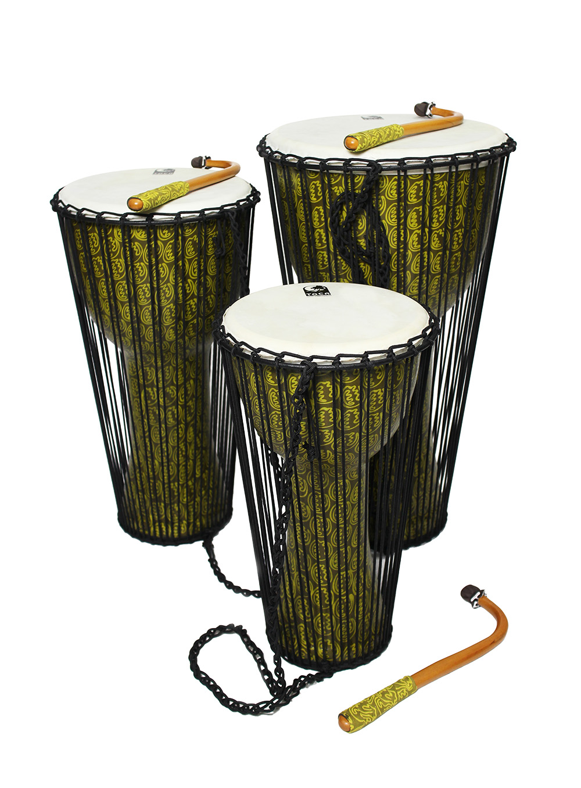
Toca Percussion proudly announces the launch of one of the most innovative percussion instruments in decades: the Toca Talking Djembe. This groundbreaking hybrid merges the deep, resonant voice of a djembe with the expressive, pitch-bending capabilities of a traditional talking drum, creating an entirely new instrument category and unlocking a world of rhythmic possibilities.

Shaped like a djembe but equipped with a full talking drum tension-cord system, the Talking Djembe represents a true synergy. It offers the full sonic range, power, and depth of a djembe, while adding the instant pitch control and “vocal” expressiveness of a talking drum. The result is an instrument capable of speaking, singing, booming, and cutting—often all within a single rhythmic phrase.

The Talking Djembe can be played in ways no single instrument has allowed before. First, like a traditional djembe, sitting, standing, or on a strap, players can perform full-volume djembe techniques - slaps, tones, and deep bass - with familiar feel and response. Second, players can use it like a talking drum while seated. They can squeeze the side cords with their legs, instantly altering pitch as they play with hands or stick, which creates fluid, speech-like inflections. Third, it can be played like a traditional talking drum. The player can tuck it under the arm, use the included curved beater, and control pitch by squeezing the cords with the arm, just like the classic “talking” technique. Because each playing method is completely functional, not a gimmick, the Talking Djembe gives percussionists a level of expressive control previously impossible in a single drum.

The Talking Djembe incorporates the core performance features of Toca’s renowned djembe line, including a hand-selected goatskin head for warmth, articulation, and authentic tone. It features low-stretch Alpine rope with braided cores for stable tuning and powerful projection, and it delivers the rich bass response and crisp rim tones characteristic of Toca Djembes. The instrument has a lightweight, durable seamless synthetic shell available in 10”, 12”, and 14” sizes and a rubber non-slip bottom for stability during energetic playing. These features are combined with the expressive technology of Toca’s updated talking drums, which include an advanced tension-cord system offering a broader tonal range than typical talking drums. This allows for highly responsive pitch control through cord compression. The instrument also comes with a traditional-style curved beater with matching handle wrap and is capable of articulating real “speech-like” phrasing for skilled players.

While traditional players will immediately recognize the heritage of both instruments, the Talking Djembe’s hybrid nature invites all drummers, educators, and creative musicians to explore new textures, new rhythmic languages, new ensemble roles, and new melodic possibilities. Its versatility makes it equally at home in drum circles, world music settings, contemporary percussion, fusion ensembles, education programs, and experimental music.

“The Talking Djembe isn’t just an evolution—it’s a genuinely new instrument,” said Jim Rockwell, Product Manager for Toca Percussion. “It blends the soul of the djembe with the voice of the talking drum. The moment you play it, you realize you’re not just getting two drums in one—you’re getting something completely new. Something inspiring.”

tocapercussion.com
rbimusic.com

