Contact: Jim Rockwell For Immediate Release
RBI Music
Tel: 201-247-7224
Email: marketing@rbimusic.com

Toca Unveils Trio of Signature Cowbells Featuring Rock Icons from Loverboy, Poison, and Godsmack
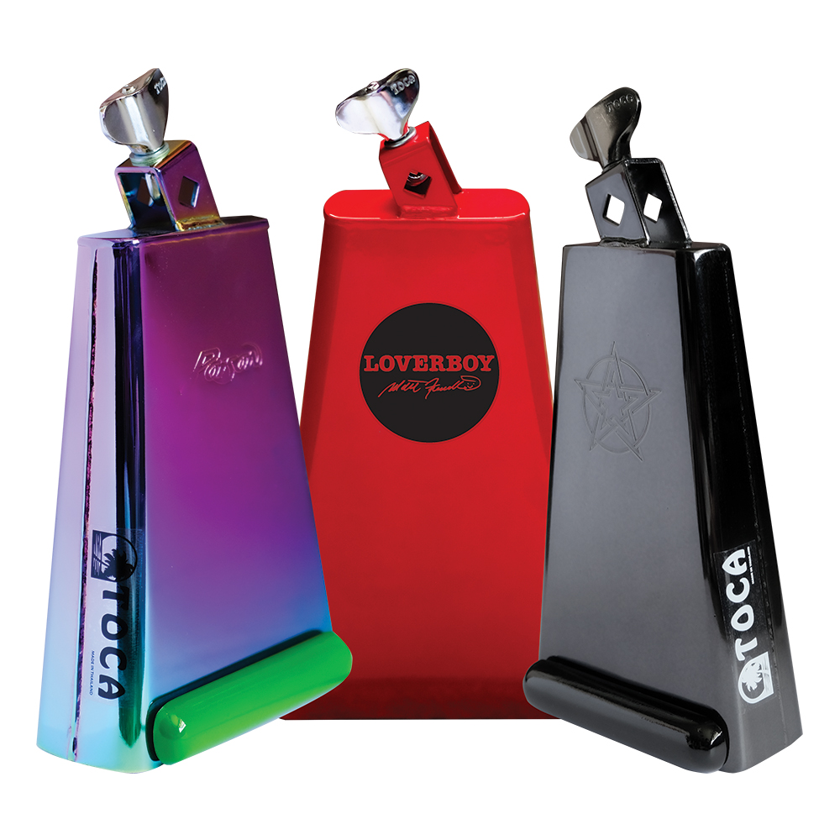
Toca Percussion proudly announces the expansion of its artist signature lineup with the introduction of three distinct new cowbells. Designed in collaboration with drumming legends Matt Frenette (Loverboy), Rikki Rockett (Poison), and Sully Erna (Godsmack), these new bells combine Toca’s trusted sonic engineering with the unique visual flair and performance requirements of rock royalty.

Channeling the driving force behind Loverboy, Matt Frenette’s signature model is a visual powerhouse. Based on the classic Toca Timbale bell, this version is finished in a striking Hot Rod Red. The upper third of the bell features a distinct circular field of black, housing the iconic Loverboy logo and Frenette’s signature. It is a bell designed to cut through the mix with the same energy as a classic rock anthem.

Poison drummer Rikki Rockett brings a splash of color to the lineup with a bell based on the Toca Timber Tone model. Utilizing the Timbale bell shape and size, this model swaps the traditional white finish for stunning anodized plating, creating a rainbow effect of blues, purples, greens, and yellows that catches stage lights from every angle.

Visually, the bell is accented by a Timber Tone Block painted in a vivid Glam Green, making it an instant standout. Both the Poison logo and Rockett’s signature are stamped directly into the metal.

The Sully Erna Signature Bell: The Dark Mirror
For a heavier, more subtle aesthetic, Godsmack founder Sully Erna, a multi-instrumentalist known for his heavy grooves, chose the Toca Mambo bell as his foundation. This bell features a sleek, black mirror chrome finish that exudes a dark elegance. It is equipped with a shiny black Timber Tone Block for dampening and features the unmistakable Godsmack "Star" stamped into the face of the bell for an everlasting impression.

tocapercussion.com

