Contact: Jim Rockwell FOR IMMEDIATE RELEASE
RBI Music
Tel: 201-247-7224
Email: jim.rockwell@rbimusic.com

Toca Eliminates Clutter with Innovative Percussion Tray Accessory Mount
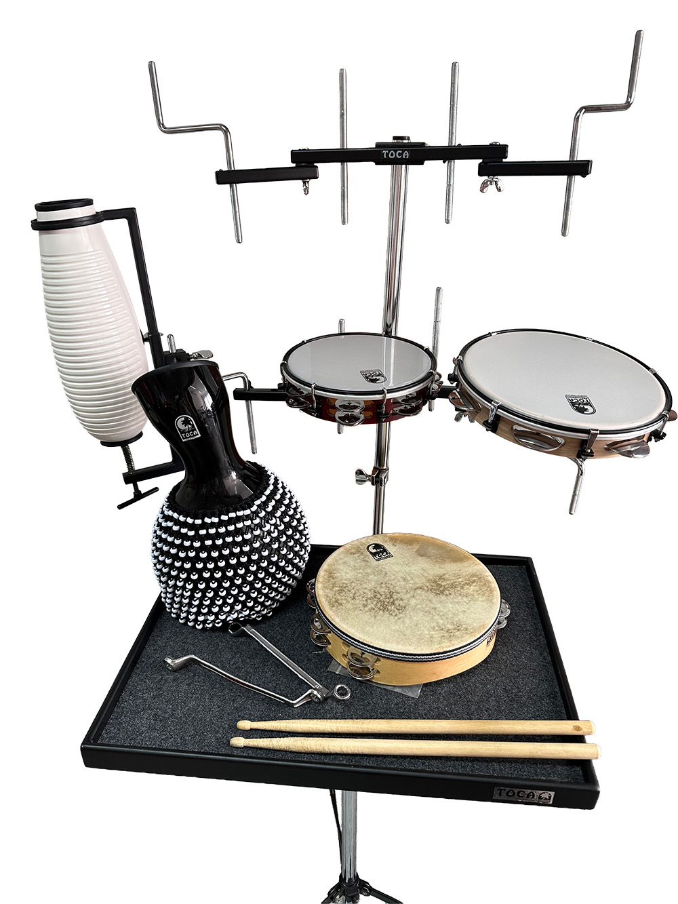
Toca announces today announced the launch of the Percussion Tray Accessory Mount. Designed to solve one of the most frustrating problems in accessory setup, the Percussion Tray Accessory Mount allows players to mount essential instruments directly onto their percussion tray without wasting valuable stage space.

For years, percussionists using trays or tables have struggled with bulky setups. Approximately 95% of trays currently on the market lack the integrated functionality to easily add clamps and mounts. This forces players to rely on cumbersome external cymbal stands placed directly in front of the table, a solution that consumes precious stage real estate. The few tables that offer integrated accessory mounts often require overly complex engineering to set up and break down.

The Toca Percussion Tray Accessory Mount provides a simple, robust, and elegant answer to this challenge.

"We heard countless drummers express frustration with the complexity and clutter associated with mounting accessories in front of their percussion tables," said Jim Rockwell, Head of Product Development at Toca. "The PTAM is designed to eliminate the frustration factor. It's a durable, universal solution that simplifies setup, saves floor space, and lets the player focus entirely on their performance."

The key to the PTAM’s versatility is its C-Clamp bongo mount, which attaches securely to the center post of virtually any standard percussion tray or table. This direct-to-post attachment instantly creates a stable mounting surface right where the player needs it, all without requiring any extra floor stands.
The PTAM is built to last and offers complete flexibility. Its adjustable height ensures the mount can be customized to meet any specific playing style. Set up and break down is designed to be a breeze, making it an ideal add-on for any working drummer or percussionist who values efficiency and a clean stage appearance.

tocapercussion.com
rbimusic.com

