Contact: Jim Rockwell FOR IMMEDIATE RELEASE
RBI Music
Tel: 201-247-7224
Email: jim.rockwell@rbimusic.com

Toca Launches Collapsible Didgeridoo and Showcases New Art Designs Inspired by Australian Culture
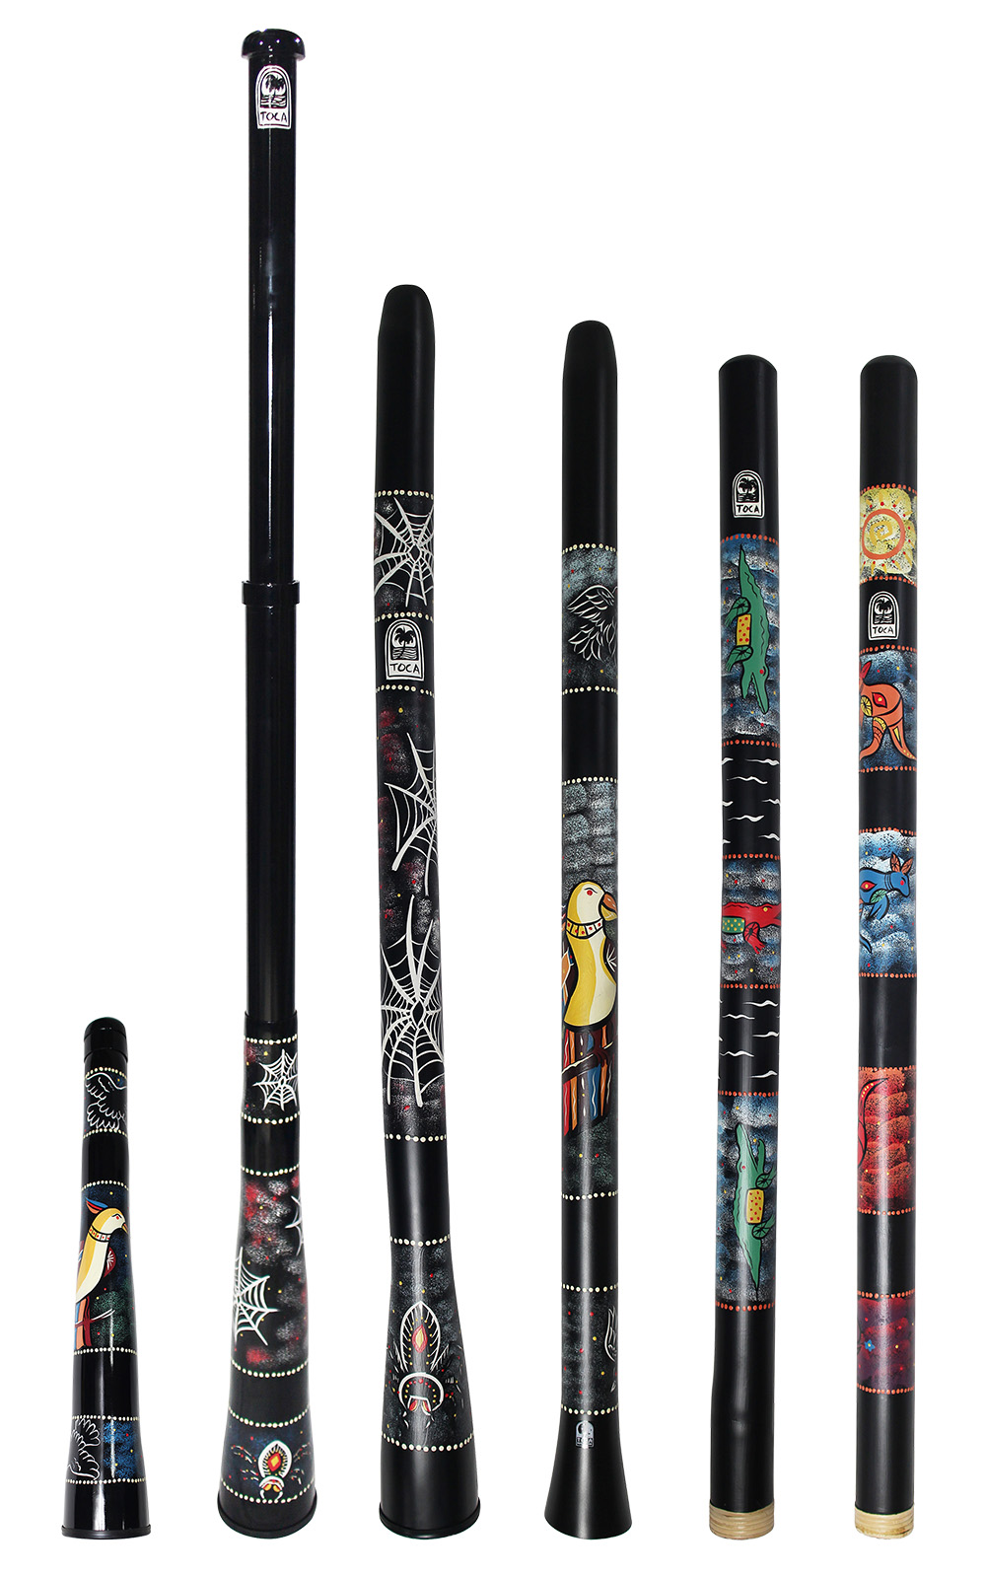
Toca today announced announced the expansion of its didgeridoo line with the introduction of the Toca Collapsible Didgeridoo. Toca is also unveiling a stunning collection of new artwork across its Bamboo, Duro, and Curved Didgeridoo models, with designs paying tribute to the rich cultural heritage and iconic fauna of Australia, the instrument's birthplace.

The New Toca Collapsible Didgeridoo: Travel-Ready Sound
The Toca Collapsible Didgeridoo is designed for the modern musician, blending authentic sound with ultimate portability. This unique, two-piece instrument expands to a full playing length to deliver a deep, resonant tone, and then smoothly contracts to a compact size, fitting easily into the included carrying bag. This portability makes it ideal for touring artists, educators, and players on the go.

The Toca Collapsible Didgeridoo removes the barrier between travel and performance. Players no longer have to sacrifice the traditional didgeridoo experience for convenience. It offers a full-size playing feel and deep, resonant tone, making it perfect for touring musicians, educators, or anyone who wants to take their practice wherever they go.

The entire Toca didgeridoo collection now features striking artwork inspired by the Australian landscape and its famous creatures, connecting the player to the instrument's cultural roots. The new designs enhance the visual appeal of the already popular Curved, Duro, and Bamboo models.

The collection features various depictions of iconic Australian fauna. The Spider design, a captivating motif rendered in a traditional style with a vibrant black, red, and yellow palette against a speckled dark background, is featured on both the Collapsible and Curved Didgeridoos. An expressive, yellow-crested Cockatoo is set against a dramatic, textured backdrop of blues and greens, and this design can be found on the Duro and Collapsible Didgeridoos. The Bamboo Didgeridoo features two separate iconic creatures: a dynamic, stylized depiction of the Kangaroo, one of Australia’s most famous marsupials, and a bold, graphic representation of the powerful Crocodile.

tocapercussion.com
rbimusic.com

