Contact: Jim Rockwell FOR IMMEDIATE RELEASE
RBI Music
Tel: 201-247-7224
Email: marketing@rbimusic.com

TOCA Unveils Industry-First: Nesting Cajons for Ultimate Portability

Three Drums, Three Unique Voices, One Compact Package!
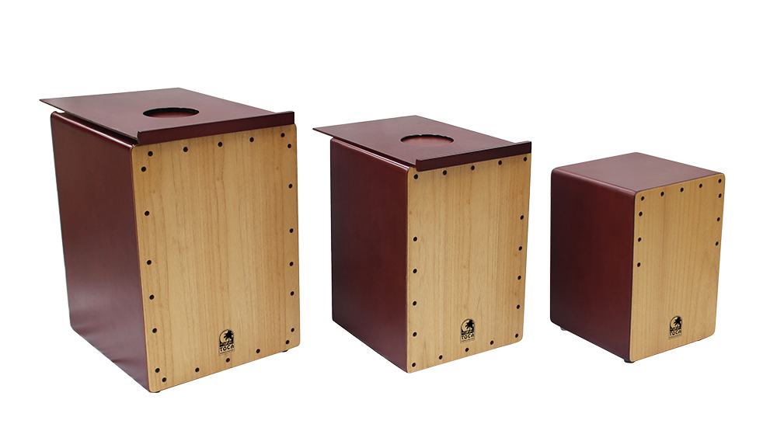
Toca Percussion today announced the launch of the groundbreaking Toca Nesting Cajons, a set of three full-featured cajons - small, medium, and large - designed to perfectly nest inside each other. This revolutionary design addresses the critical need for space-saving storage and maximum portability in educational settings, drum circles, recreational markets, and corporate events.

The Toca Nesting Cajons offer an unprecedented solution for drummers on the go. The core of this innovation is found in the medium and large cajons, which feature a clever sliding door on the back panel. This door allows each sequentially smaller drum to be securely stored inside the next larger one. The entire three-drum ensemble collapses down to the compact footprint of the largest cajon, making transport and storage remarkably effortless, a key advantage for places where conservation of space is needed.

Beyond their innovative nesting design, the cajons are engineered to function as a versatile percussion ensemble. The Small Cajon is tuned to produce clear, cracking snare snaps for high-end accents and sharp rhythms. The Medium Cajon delivers warm, balanced mid-tones, perfect for groove and melody. Finally, the Large Cajon provides a deep, booming bass foundation for powerful backbeats. While the three drums create a wonderful ensemble of complementary sounds when played together, each cajon is a standalone, quality instrument capable of fulfilling its own rhythmic role.

The instruments are crafted with both durability and beauty in mind. The sound box will be painted in a rich Red Mahogany and paired with a White Teak front plate (Tapa).

"The Nesting Cajons are a direct result of listening to the needs of music educators and facilitators. Portability and efficient storage are huge challenges, especially for groups and classroom settings,” says Jim Rockwell, Head of Product Development at Toca. “We’ve solved this with a design that is truly a first for the market, delivering three distinct, professional-sounding instruments that collapse into one incredibly compact unit. It’s perfect—for anywhere rhythm takes you."

The Toca Nesting Cajons are an ideal solution for schools, music therapists, community centers, and any percussion enthusiast seeking premium sound quality without sacrificing space or ease of transport.

tocapercussion.com

