Contact: Jim Rockwell FOR IMMEDIATE RELEASE
RBI Music
Tel: 201-247-7224
Email: marketing@rbimusic.com

Toca Percussion Welcomes Jessie Caraballo to Its Artist Roster

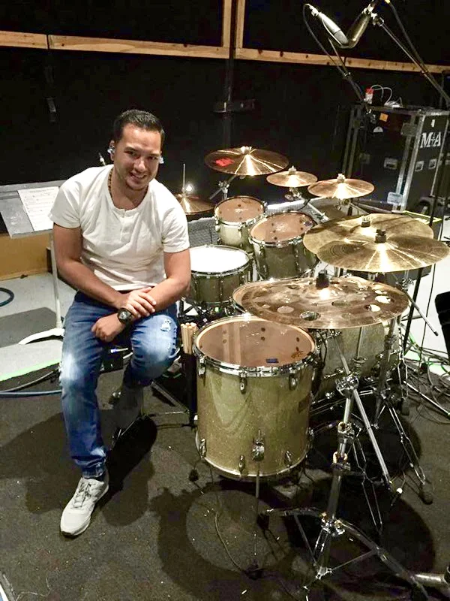
Toca Percussion is proud to welcome world-class drummer and percussionist Jessie Caraballo to its artist lineup.
Known for his precision, musical versatility, and commitment to his craft, Jessie brings decades of experience performing on some of the biggest stages in Latin and pop music.

Born in Springfield, Massachusetts, Jessie began playing drums at the age of six in his family’s band and turned professional as a teenager. By sixteen, he was performing with Latin pop artist Brenda K. Starr, which led to a long list of collaborations with major artists including Marc Anthony, Jennifer Lopez, Don Omar, Tito Nieves, Gilberto Santa Rosa, and Yandel. His career has taken him to stages around the world and television appearances such as Saturday Night Live, The Tonight Show with Jay Leno, The Latin Grammys, and PBS Fiesta Latina at the White House.

“I’m honored to be part of the Toca Percussion family,” said Jessie Caraballo. “Their instruments give me the sound and feel I need for any setting - live, in the studio, or on tour. I’m looking forward to what’s ahead with the team at Toca.”
“Jessie is an outstanding percussionist with a deep understanding of his instrument,” said Mark Petrocelli, Artist Manager at Toca. “His professionalism, talent, and experience make him a great addition to the Toca lineup.”

tocapercussion.com

