Contact: Jim Rockwell FOR IMMEDIATE RELEASE
RBI Music
Tel: 201-247-7224
Email: jim.rockwell@rbimusic.com

Toca Hannah Welton Signature Auxiliary Snare: A Fusion of Funk and Innovation
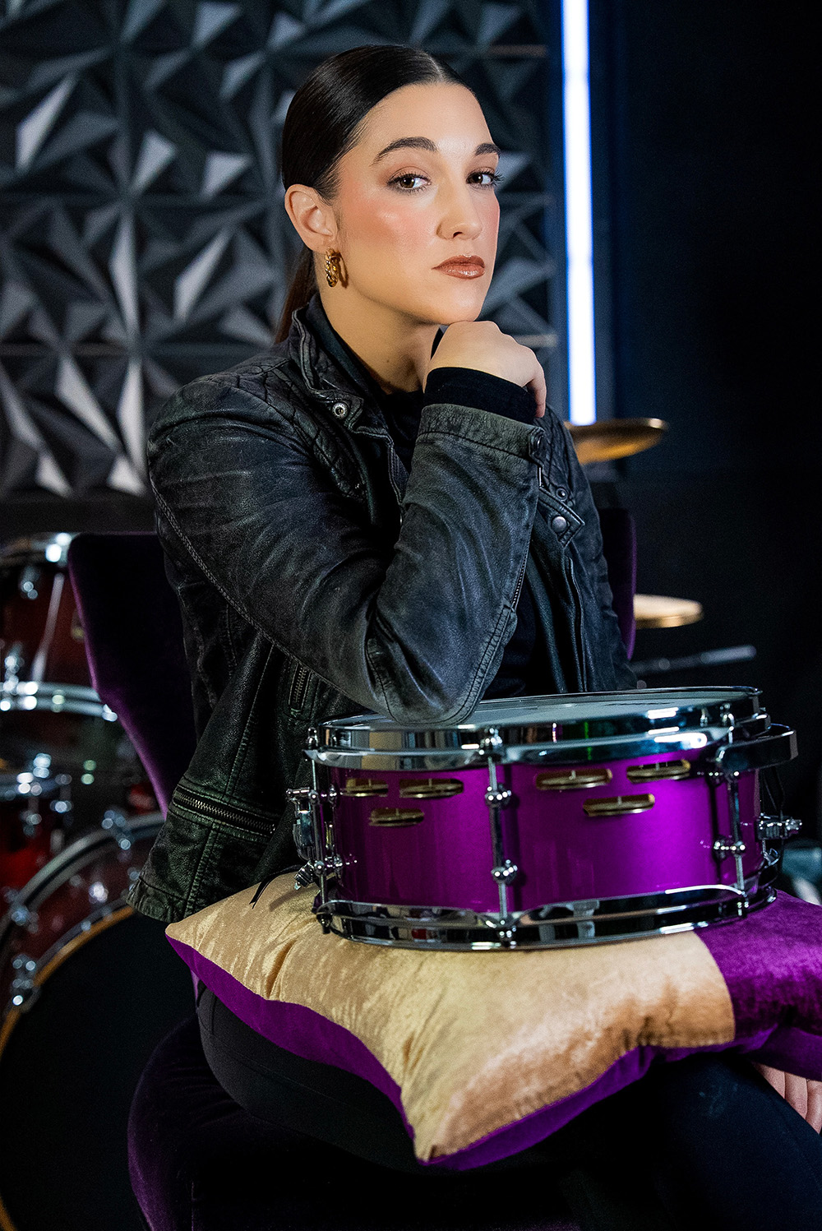
Toca Percussion is thrilled to announce the launch of the Hannah Welton Signature Auxiliary Snare, a groundbreaking instrument designed in collaboration with the celebrated drummer of Prince’s 3rdeyegirl. Born from a desire to evolve the concept of a hybrid drum, this new release combines high-end maple construction with precision-engineered jingle technology, wrapped in a stunning aesthetic that pays homage to music history.

The genesis of this unique instrument lies in Welton's long-standing affinity for the discontinued Toca Jingle Snare. While she admired the snappy response and bright tambourine-snare combination of the original accessory, she sought an instrument that offered the physical presence and playability of a true drum set component. The result is a substantial 5-inch depth by 12-inch diameter maple shell that bridges the gap between a standard snare and an auxiliary percussion piece.

"The inspiration started with my love for the original Toca Jingle Snare, specifically that snappy rim shot resonance, but I wanted an instrument that looked and felt like a true drum set drum," said Hannah Welton. "We’ve created something that isn't just an accessory, but a core voice in my kit. The Hot Purple finish is incredibly meaningful to me, serving as a memory of my time with Prince, while the German silver jingles give it a sound that is entirely my own."

Transforming the concept into a professional-grade drum required significant engineering. Unlike smaller, lighter accessory drums, a heavier maple shell with a full head size does not naturally activate jingles with a simple stick strike. To solve this, Toca’s development team utilized a floating mount system that allows the drum to move more freely when struck, generating the kinetic energy necessary to aid in the further shaking of the jingles. This mechanical advantage is paired with a configuration where double-row jingles are offset and positioned as close to the rim as possible to capture maximum vibration from both the rim and head impact. Toca further collaborated with their sister company, Grover Pro Percussion, to identify the optimal jingle alloy for the project. They selected custom-made German silver jingles to provide the most resonance and sustain, while also utilizing Grover Pro’s expertise to determine the exact shape of the jingle hole and the diameter and length of the jingle pin.

"Reimagining the jingle snare concept for a professional 5x12 maple shell required some genuine old-fashioned problem solving," said Jim Rockwell, Head of Product Development at Toca. "We couldn't just drill holes in a shell; we had to ensure the jingles would sing on a heavier drum. By partnering with the experts at Grover Pro Percussion to dial in the exact jingle alloy and pin mechanics, we achieved a perfect balance. This drum offers the sensitivity Hannah requires with a distinct tonal character that you can’t get from any other snare on the market."

The drum is outfitted with premium components to match its unique sound, featuring an Evans HD Dry batter head, an Evans Hazy 300 resonant side, and a Puresound P1420 20-strand snare wire. The shell is finished in a vibrant "hot purple" lacquer, chosen to honor Prince and complement Welton’s personal branding, while the chrome hardware adds a sleek, modern touch. Hannah’s Lioness logo is featured on a chrome badge and printed directly on the drum head in purple. The drum comes complete with a floating mount for easy positioning.
Hannah Welton creates a powerful backdrop for this signature release. A rhythmic prodigy who began playing professionally at age twelve, she was recruited by Prince in 2012 after he viewed her performance videos online. She served as the drummer for his backing band 3rdeyegirl and the New Power Generation, touring globally and recording the album Plectrumelectrum. Her experience playing fusion, blues, and rock at the highest level has culminated in a signature instrument designed to meet the rigorous demands of professional touring while delivering a one-of-a-kind sound.

tocapercussion.com
rbimusic.com

