Contact: Jim Rockwell FOR IMMEDIATE RELEASE
RBI Music
Tel: 201-247-7224
Email: jim.rockwell@rbimusic.com

Toca Unveils First-Ever Signature Timbale Stick in Collaboration with Eric Velez
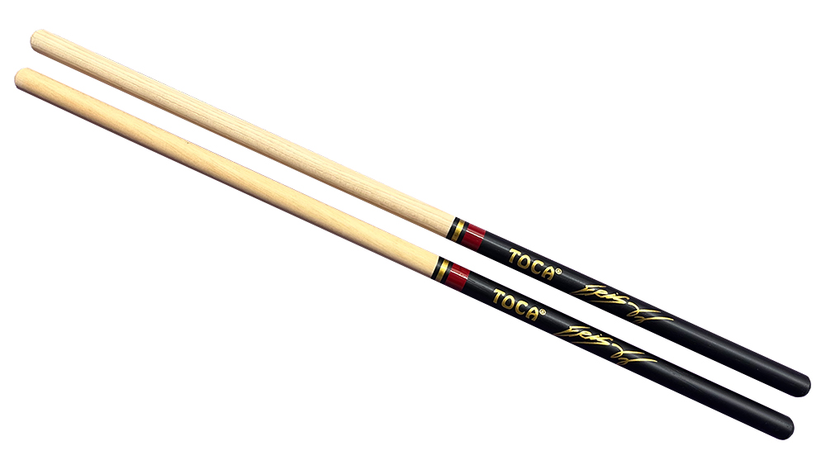
Toca Percussion is proud to announce a historic addition to its product lineup with the launch of the Eric Velez Signature Series Timbale Sticks. This release marks a significant milestone for the brand as the first time Toca has introduced a signature timbale stick, further cementing its commitment to providing world-class tools for Latin percussionists. Designed in close collaboration with the renowned percussionist, these sticks are precision-engineered to bridge the gap between high-performance functionality and striking visual artistry.

The Eric Velez Signature Series Timbale Sticks were created to meet the exacting requirements of Velez’s dynamic playing style and rigorous performance demands. Moving away from standard dimensions, these sticks feature a unique specification profile with a sixteen-inch length and a precise 0.462-inch diameter. This custom sizing provides the specific balance, speed, and rebound necessary for the intricate sticking and power that defines Velez’s sound. The result is a tool that feels like a natural extension of the player's hand, capable of delivering cutting rimshots and articulate cascara patterns with ease.

"Collaborating with Eric Velez is always an inspiring process because of his deep understanding of the mechanics of performance," said Jim Rockwell, Head of Product Development at Toca Percussion. "We worked tirelessly to dial in the exact dimensions he needed, specifically that unique 0.462-inch diameter, to create a stick that offers a completely unique feel compared to standard models. This isn't just a standard stick with a signature stamped on it; it is a tailored instrument designed to match the specific energy and precision Eric brings to every stage."

Visually, the sticks are designed to serve as a perfect companion to the existing Eric Velez Signature Series instrument line. The aesthetic creates a seamless visual suite when paired with his Arandano-Rojo finished congas, bongos, and timbales. The design features a sleek black grip that transitions into the natural wood of the shoulder and tip, separated by a distinct banding pattern near the stick's midpoint. This design includes a substantial band of metallic Arandano-Rojo red, bordered by a smaller, elegant band of Rose Gold. It is then highlighted with Eric Velez’s signature and the Toca logo, both stamped in a matching Rose Gold to capture the essence of the artist's style.

tocapercussion.com
rbimusic.com

