Contact: Rick Taylor
RBI Music
Tel: 817-335-2561 x105
Email: rick.taylor@rbimusic.com

Silvertone Unveils Updated 1478: Iconic Offset Style Meets Modern Upgrades

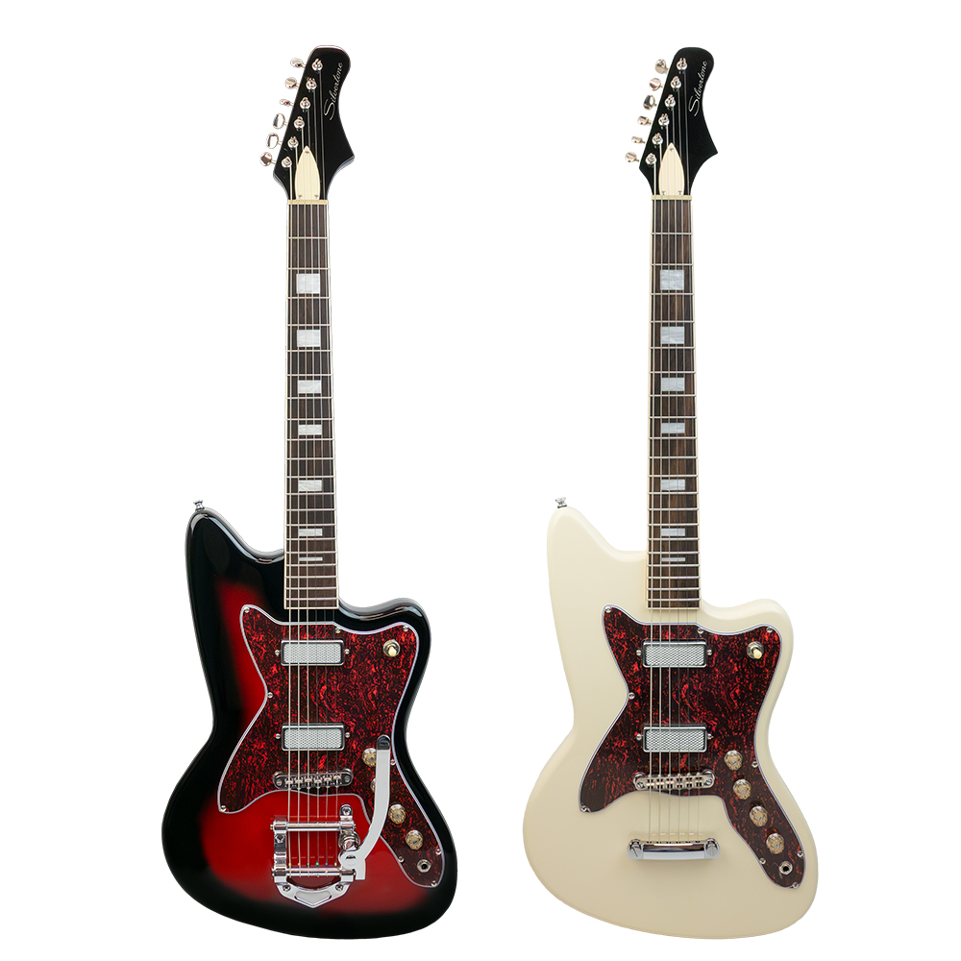
It’s time to reset the offset.

Silvertone is proud to announce a series of significant updates to its current 1478 RSB (Red Silver Burst) model—enhancing performance, comfort, and tonal versatility while preserving the unmistakable look and soul of one of the brand’s most iconic offset guitars.

First introduced in 1964, the Silvertone 1478 earned its reputation through its recognizable red sunburst finish, Jazzmaster®-influenced contours, bound fingerboard, block inlays, and status as the first Silvertone equipped with a vibrato tailpiece. While the model has evolved over the decades, its vintage mojo remains a favorite among gigging musicians, recording artists, and collectors.

With the new updates, Silvertone brings that heritage forward—refining the instrument for today’s modern players.

Modern Performance, Classic Silhouette

The updated 1478 RSB has been carefully re-engineered by the Silvertone design team to provide an elevated playing experience without sacrificing its classic character.

The original “2-by-4 lumber” neck profile has been redesigned into a modern-taper 24 ¾” scale, C-shape neck that immediately feels comfortable and familiar. The original-style surface-mount pickups have been replaced with custom Silvertone® Silver Foil pickups housed in an industry-standard mini-humbucker case—fully adjustable and optimized for clarity, balance, and dynamic response.

A new Tune-o-matic–style bridge with roller saddles ensures smooth, reliable tuning stability even under heavy vibrato use.

“These upgrades were all about honoring the original vibe of the 1478 while giving players a more refined, stage-ready instrument,” says Rick Taylor, Silvertone Product Manager. “We focused on feel, stability, and tone—things modern guitarists demand—without changing what people already love about the 1478. It still has that unmistakable Silvertone swagger, but now it plays better than ever.”

Updated Construction for Today’s Player

Two versions of the 1478 are available. The 1478V features a vibrato tailpiece that works seamlessly with a Tune-o-matic style bridge featuring roller saddles for exceptional tuning stability, and the 1478S with a ‘Stop’ tailpiece. The refreshed 1478 RSB features a mahogany body with a maple top and back, paired with a 24 ¾” scale mahogany neck carved into a smooth C profile. A rosewood fingerboard with advanced semi-hemispherical frets delivers improved comfort, faster movement, and a more polished feel up and down the neck—perfect for both live performance and home recording sessions.

Enhanced Vintage-Inspired Tone
The original DeArmond® pickups on early 1478s were beloved for their chimey highs and woody midrange, reminiscent of P-90 and lipstick-style pickups. The new custom noiseless Silver Foil pickups capture that spirit but expand it—offering a bright, focused, and articulate tone that sits comfortably between overwound single-coils and traditional humbuckers. They excel with clean tones, overdriven tube amp crunch, and even modern digital amp and effects setups.

Fully adjustable and built into standard mini-humbucker-sized housings, these pickups provide exceptional string-to-string balance and versatility.
Available in three colors:
1478V in Red Sunburst
1478S in Vintage White
1478S in Pelham Blue

For more information about Silvertone, please visit SilvertoneGuitars.com
Silvertone Guitars is a wholly owned brand of RBimusic.

