Contact: Rick Taylor FOR IMMEDIATE RELEASE
RBI Music
Tel: 817-335-2561 x105
Email: rick.taylor@rbimusic.com

The One and Only… Silvertone Announces Modern Upgrades to the Iconic 1449 Guitar

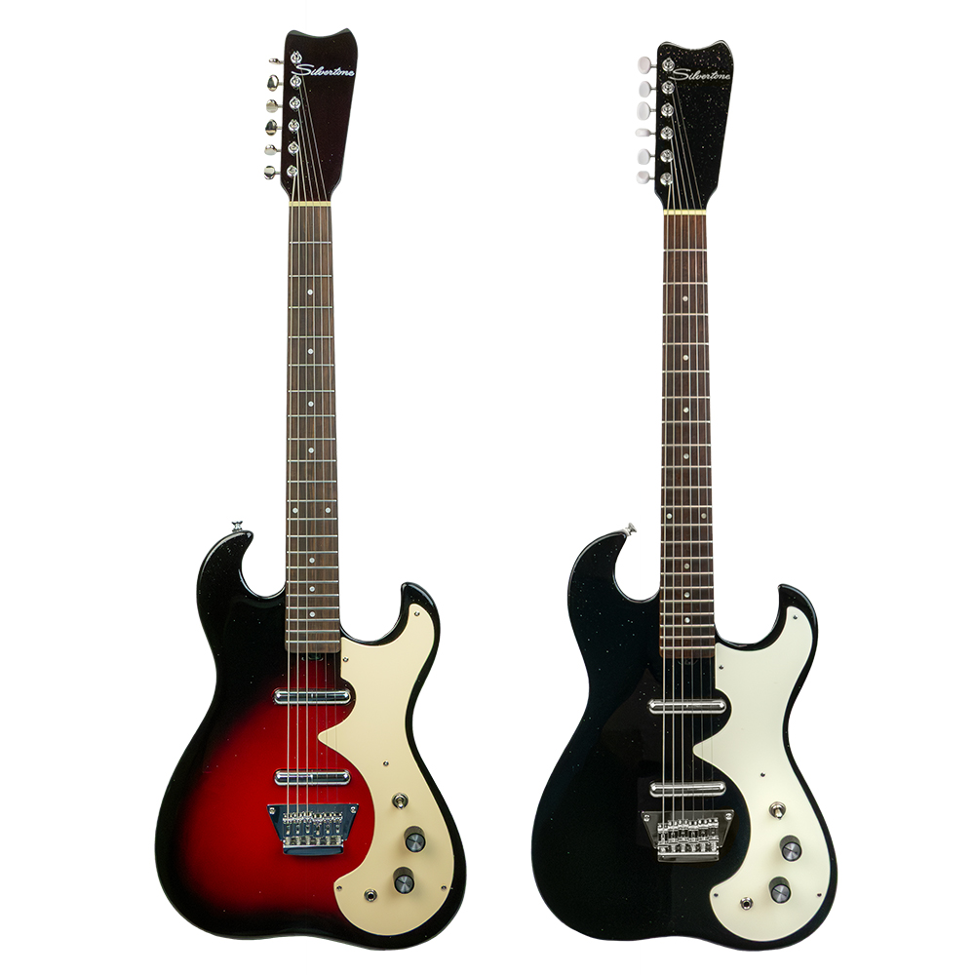
Silvertone is excited to announce significant performance upgrades to the legendary Model 1449 electric guitar. The 1449, a two-pickup evolution of the original 1962 "Amp in Case" Model 1448, remains a favorite of recording artists like Neil Young and Beck, and has been a successful part of Silvertone’s reissued lineup for years. These new enhancements continue to capture the vintage soul of the instrument while offering an elevated playing experience.

The Silvertone design team has integrated modern performance features into the already iconic design. The guitar features a solid mahogany body joined to a soft "C" shaped, 24 ¾” scale mahogany neck. The rosewood fingerboard is now fitted with state-of-the-art "Semi-Hemispherical" frets, providing a smoother, faster feel across the neck. Adjusting the neck relief is now fast and effortless thanks to a convenient "spoke wheel" truss rod. The bridge has been upgraded with independently adjustable solid brass saddles, ensuring perfect intonation.

The electronics retain their vintage mojo through all new custom-wound, Silvertone custom "Lipstick" single coil pickups. These pickups, celebrated for their jangly, chiming, clear, and detailed tone, utilize a vintage correct Alnico 6 bar magnet and 42 AWG "Plain Enamel" coil wire, just like the originals created by Nathan Daniel. For improved performance, the neck pickup is built Reverse Wound / Reverse Polarity from the bridge model, offering hum-cancelling operation when both pickups are used. The bridge pickup has a slightly increased output (DCR: 4.3K) to perfectly balance with the neck position pickup (DCR: 3.8K). Controls include a 3-way switch, one volume, and one tone control, all topped with all-new custom retro "barrel" knobs that celebrate the unique vintage vibe of Silvertone.

The 1449 also features a 12-inch radius rosewood fingerboard with pearloid dot inlays and Kluson® vintage style tuners.

“The Silvertone 1449 has always been about combining unique style with amazing tone,” said Guitar Product Manager, Rick Taylor. “These new upgrades, especially the Semi-Hemispherical frets and the spoke wheel truss rod, significantly enhance the playability and setup experience, ensuring that this guitar is not just a beautiful reissue, but a truly professional tool ready for the stage and studio.”

The updated Silvertone 1449 is available in three striking colors: Red Sunburst, Black Silver Flake, and Heavy Silver Flake.

For more information about Silvertone, please visit SilvertoneGuitars.com
Silvertone Guitars is a wholly owned brand of RBimusic.

