Contact: Rick Taylor Embargoed Until January 16, 2026
RBI Music
Tel: 817-335-2561 x105
Email: rick.taylor@rbimusic.com

Silvertone® Announces the Return of the Iconic 1446

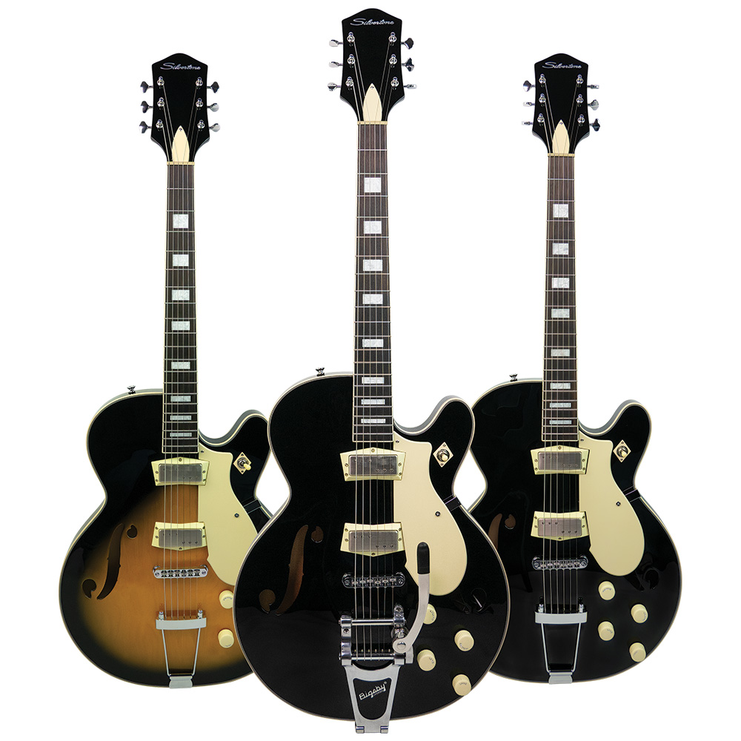
Silvertone has reintroduced the iconic 1446 semi-hollow electric – one of the most recognizable guitar models in rock history.

Played by legendary artists Chris Isaak, Elvis Costello, Hubert Sumlin and more, the Silvertone 1446 is now, for the first time in decades, that sound - and that guitar - can be yours.

Originally sold through the Sears catalog from 1961 to 1967, the Silvertone 1446 holds a special place in electric-guitar history. Over the last 60 years it has become one of the most sought-after models among recording artists and collectors.

Now, Silvertone proudly reintroduces the 1446 - meticulously recreated with modern performance features while honoring every detail that made the original a legend.

A Classic Reborn for the Modern Player

The new Silvertone 1446 delivers enhanced playability and tonal versatility while maintaining its iconic silhouette. The original “2×4 lumber” neck profile has been re-engineered into a comfortable modern-taper soft-C shape. A chambered center-block maple body improves sustain, reduces feedback, and opens up the guitar’s dynamic range - perfect for the demands of today’s stages and studios.

Two versions of the 1446 are available. The 1446V, in Black, features a genuine Bigsby® B70 vibrato tailpiece that works seamlessly with a Tune-o-matic style bridge featuring roller saddles for exceptional tuning stability, and the 1446T, in Black or Tobacco Sunburst, with a ‘Trapeze’ tailpiece. The 24 ¾” scale mahogany neck and rosewood fingerboard feature state-of-the-art “Semi-Hemispherical” frets for an ultra-smooth playing feel.

Vintage Mojo, Recreated with Precision

One of the most revered elements of the original 1446 was its pickups - mini humbuckers designed by Seth Lover and manufactured exclusively for Silvertone. Known as the P19, these rare pickups had a unique 3+3 pole-piece design and a distinct, lower-wind voice.

To recreate this sonic magic, Silvertone collaborated with renowned designer Trev Wilkinson. His new Wilkinson “R Series” mini-humbuckers are exacting, era-specific recreations featuring custom tooling, period-correct Alnico V magnets, and carefully matched winding. The result: the unmistakable clarity, warmth, and harmonic glide that made the 1446 famous.

“When you pick up this guitar, you immediately understand why the original became such a cult classic” says Silvertone Product Manager, Rick Taylor. “We set out to deliver the soul of the 60’s 1446, but with the playability and reliability modern musicians expect. Whether you’re chasing that famously haunting Wicked Game intro or carving out a completely new sound, the new 1446 gives you inspiration from the moment you plug in.”

For more information about Silvertone, please visit SilvertoneGuitars.com
Silvertone Guitars is a wholly owned brand of RBimusic.

