**Contact:** Jim Rockwell **Embargoed Until January 23, 2025**

RBI Music

**Tel:** 201-247-7224

**Email:** marketing@rbimusic.com

**Toca Timber Tone™️ Cowbell: A Revolutionary Addition to the World of Percussion**

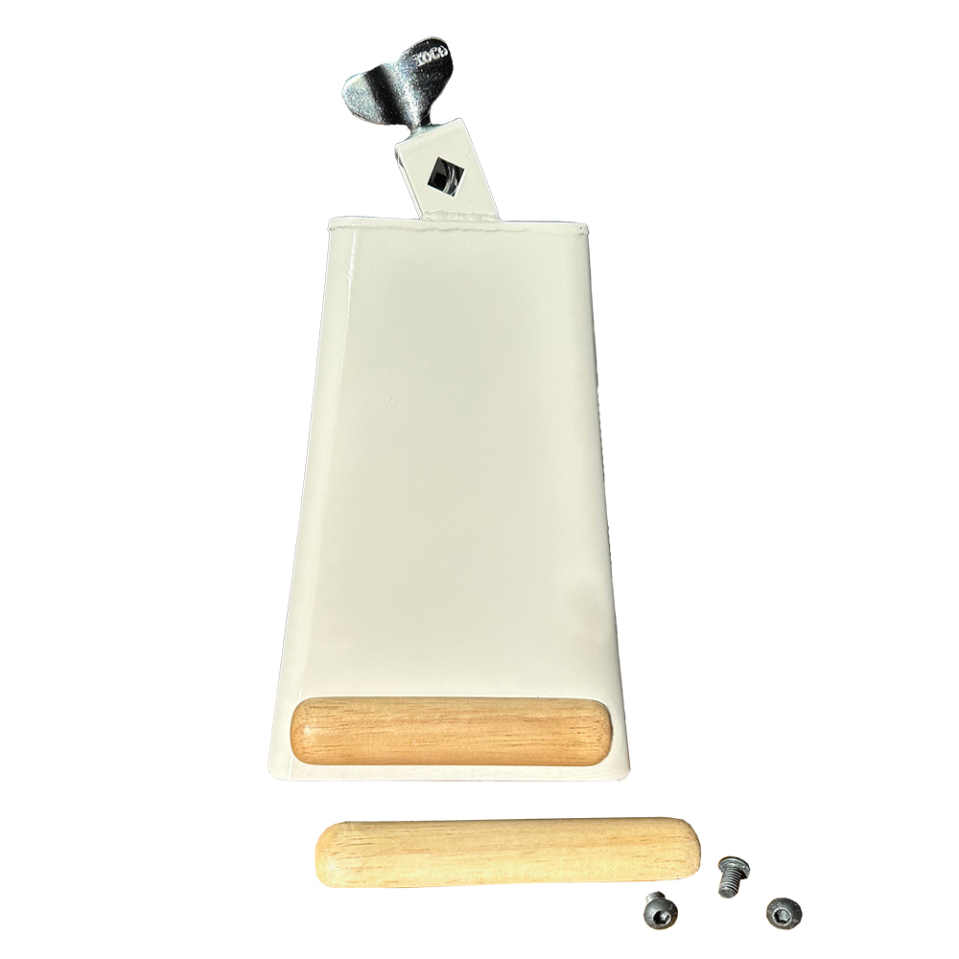Toca Percussion excitedly announces the launch of the Timber Tone™️ Cowbell, a groundbreaking innovation in the world of percussion. Designed for versatility, durability, and exceptional sound quality, this unique cowbell is set to redefine what percussionists can expect from their gear.

At the core of the Timber Tone’s uniqueness lies a small wooden block attached near the mouth of the bell. This innovative feature not only reduces overtones but also ensures a pure, focused tone with less metallic harshness. The result is a rich, full-bodied sound that strikes the perfect balance between projection and tonal clarity, making it ideal for both live performances and studio sessions.

Crafted from premium steel, the Timber Tone Cowbell is built to endure even the most rigorous playing. The robust construction ensures reliability across high-energy performances, from Latin rhythms to rock and funk grooves.

Equally as important as the sound, the wooden block is replaceable. If it breaks, percussionists can easily unscrew the fasteners, swap out the block, and restore the bell to its original performance standard.

This distinct combination of sound quality, innovation, and durability positions the Timber Tone Cowbell as a must-have for percussionists across genres. Whether providing intricate rhythms or powerful accents, the Timber Tone adapts effortlessly to a wide range of musical styles, from salsa and merengue to pop and rock.

“We’re always looking for ways to elevate the percussion experience, and the Timber Tone Cowbell delivers on all fronts,” said Jim Rockwell, Toca’s Product Manager. “With its unique wooden block design, it offers unparalleled tonal focus while remaining durable and easy to maintain. We believe this will quickly become an essential tool for drummers and percussionists at every level.”

tocapercussion.com