**Contact:** Jim Rockwell **Embargoed Until January 23, 2025**

RBI Music

**Tel:** 201-247-7224

**Email:** marketing@rbimusic.com

**Synergy Congas and Bongos Available in Stunning Matte Ocean Blue and Racing Red**

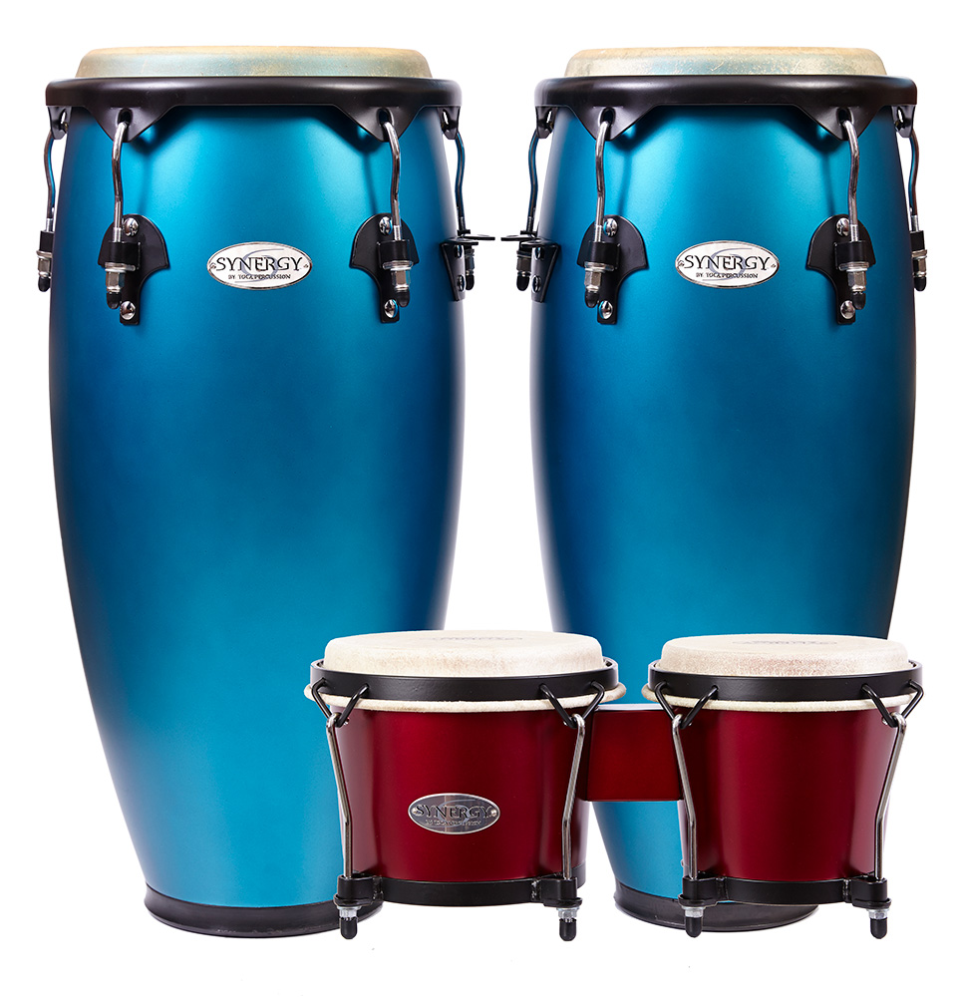Toca Percussion breathes new life into its popular Synergy Congas and Bongos by introducing two bold new colors: Ocean Blue and Racing Red, both in a sleek matte finish. These vibrant additions bring a fresh, modern aesthetic to a line already celebrated for its exceptional sound quality and craftsmanship.

The Synergy Congas, featuring 28-inch two-ply wood shells with 10-inch Quinto and 11-inch Conga rawhide heads, now sport these striking finishes that elevate their stage presence. Paired with black powder-coated hardware and mounted on a double-braced conga stand, these drums not only sound incredible but look stunning in any performance setting.

The Synergy Bongos, crafted from durable Asian oak shells with 6-inch and 7-inch rawhide heads, also get the matte treatment. The bold Ocean Blue and Racing Red finishes perfectly complement the black powder-coated hardware and traditional hoops, enhancing their visual appeal while maintaining their bright, crisp sound and high tonal range.

Toca’s commitment to sustainability remains at the heart of the Synergy line. The wood for these instruments is responsibly sourced from a plantation, where local artisans handcraft each drum with precision and care. This eco-friendly approach ensures that the Synergy Congas and Bongos deliver exceptional performance while minimizing their environmental impact.

Jim Rockwell, Product Manager for Toca, highlights the significance of these new additions: “We always want to give musicians more ways to express themselves, both sonically and visually. The new Ocean Blue and Racing Red matte finishes on the Synergy Congas and Bongos bring a fresh, modern look to a trusted line, all while staying true to Toca’s dedication to quality and sustainability.”

tocapercussion.com