**Contact:** Jim Rockwell **Embargoed Until January 23, 2025**

RBI Music

**Tel:** 201-247-7224

**Email:** marketing@rbimusic.com

**New Rawhide Maracas, Blending Authenticity and Craftsmanship**

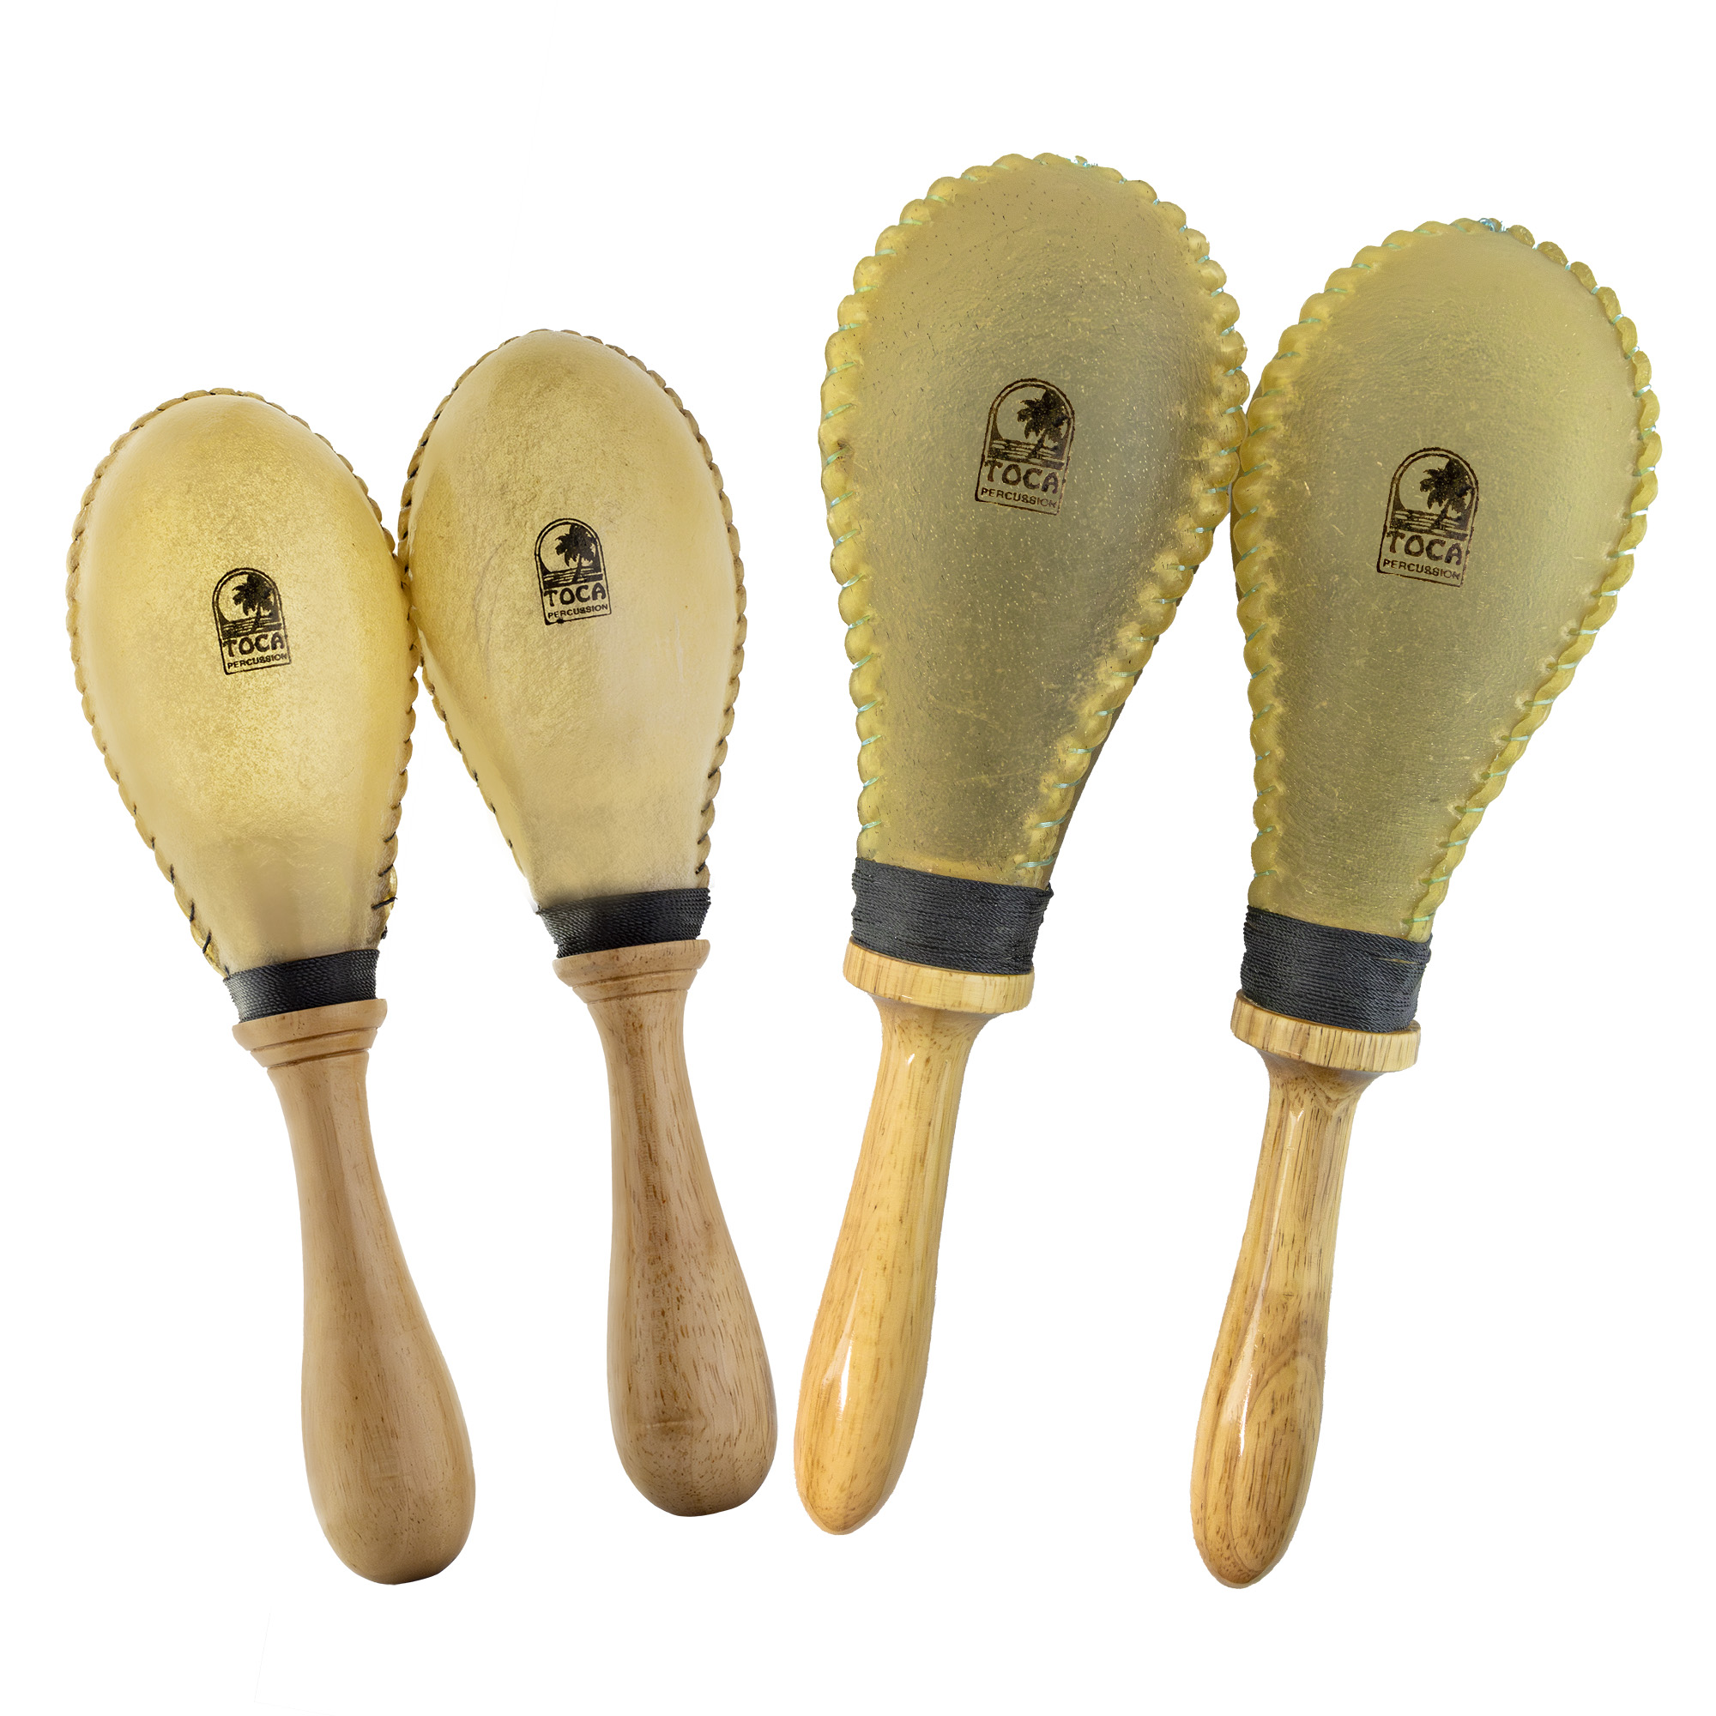

Toca Percussion is happy to announce the launch of two new models of rawhide maracas, available in medium and large sizes. Designed for musicians who value authenticity and dynamic sound, both models are sold in matched pairs with natural rawhide shells and wooden handles. The large-sized maracas also come with an attractive and practical cloth carrying bag, making them perfect for musicians on the go.

Toca’s rawhide maracas honor the traditions of Latin American music, showcasing handcrafted appeal and cultural authenticity. Rawhide’s natural texture and variations in thickness create visually distinct instruments, making each pair unique. This attention to detail ensures that musicians are not just playing an instrument, but a work of art.

Durability is another hallmark of Toca’s rawhide maracas. The rawhide material is resilient, withstanding years of use while maintaining its tonal integrity.

The lightweight construction and balanced weight of the maracas provide a comfortable grip for extended play, ensuring they are as practical as they are beautiful. For environmentally conscious musicians, rawhide is an eco-friendly choice, as it is biodegradable.

Jim Rockwell, Product Manager for Toca, emphasizes the blend of tradition and innovation these maracas bring to the table: “Our new rawhide maracas are designed for musicians who want more than just a percussion instrument—they want an authentic connection to tradition. The warmth and dynamic range of these maracas, combined with their handcrafted quality, make them an essential tool for players who demand the best in both sound and aesthetics.”

tocapercussion.com