**Contact:** Jim Rockwell **Embargoed Until January 23, 2025**

RBI Music

**Tel:** 201-247-7224

**Email:** marketing@rbimusic.com

**Toca Introduces Low-Profile Collapsible Conga Barrel Stand with Wheels**

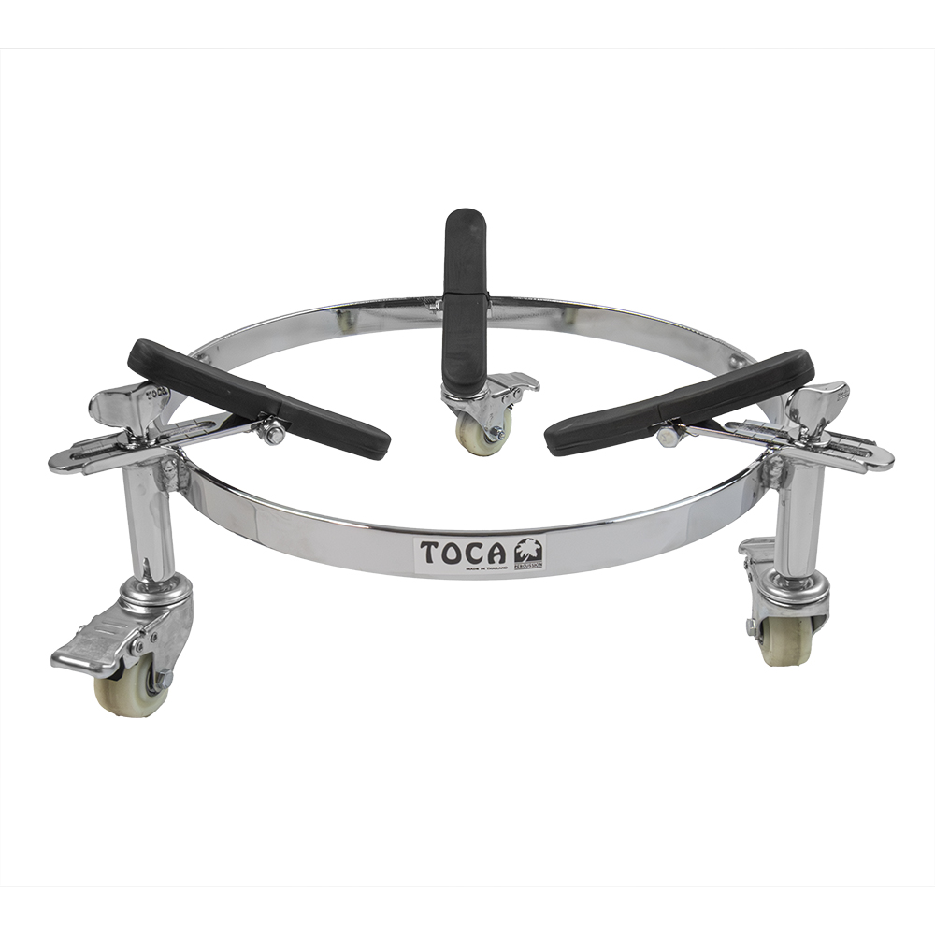

Toca Percussion announces the launch of the Low-Profile Collapsible Conga Barrel Stand, an innovative addition to its lineup of premium percussion gear. Designed with seated players in mind, this stand combines compactness, mobility, and durability to provide an unmatched experience for percussionists of all levels.

Standing just 4 inches off the ground, the new Low-Profile Barrel Stand is perfect for players who prefer seated setups. Built from heavy-gauge, chrome-plated steel, it is lightweight yet impressively sturdy, with a tripod design that ensures stability during performances. Despite its robust construction, the stand is easily portable, with a collapsible design that fits neatly into gig bags or road cases—perfect for musicians on the move.

One of the standout features of this new design is the inclusion of high-quality wheels, making it effortless to roll drums across a variety of surfaces. Each wheel is equipped with a locking mechanism, ensuring the stand remains stationary during play. This combination of mobility and security makes it a versatile tool for any setting, whether on stage, in a studio, or at a casual jam session.

The Low-Profile Collapsible Conga Barrel Stand also offers percussionists an unmatched level of convenience during setup. Drum size demarcation lines allow for quick, precise adjustments, ensuring the rubber grippers fit perfectly to your drum’s dimensions every time. These thoughtful details simplify the process, letting players focus on their music rather than their gear.

“This stand was designed with the working musician in mind,” said Jim Rockwell, Toca Product Manager. “From its compact design to the mobility offered by its wheels, it’s built for convenience without compromising stability or performance. Whether you’re a seated player or someone always on the go, this stand will exceed your expectations.”

tocapercussion.com