**Contact:** Jim Rockwell **Embargoed Until January 23, 2025**

RBI Music

**Tel:** 201-247-7224

**Email:** marketing@rbimusic.com

**Toca Expands KickBoxx Line with Four Innovative Accessories**

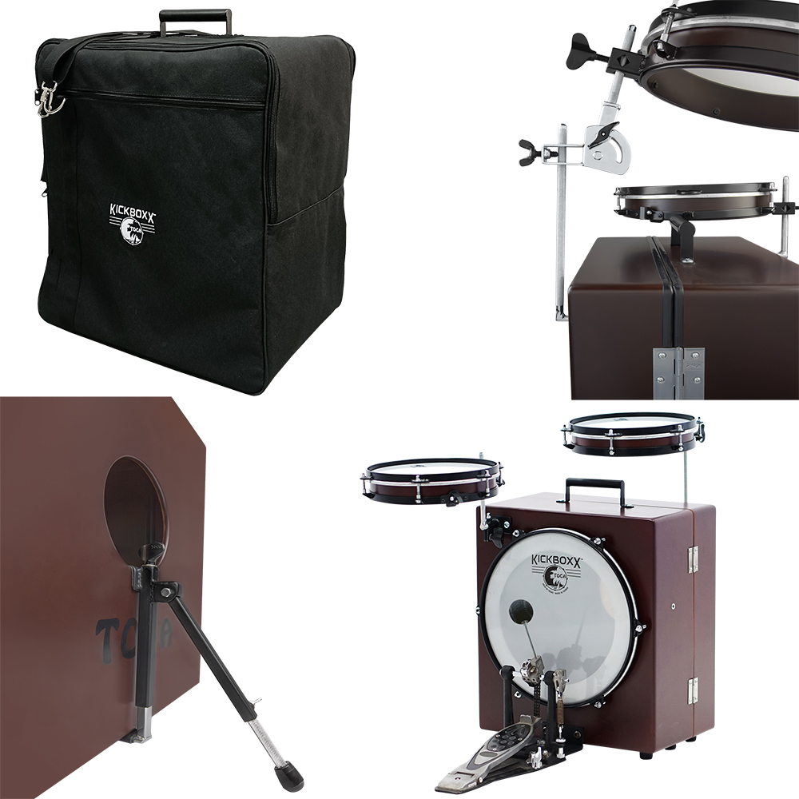

Toca Percussion is proud to announce the release of four new accessories designed specifically for its popular KickBoxx Suitcase Drum Set line. These new additions reflect Toca’s commitment to listening to its community of professional artists and customers, bringing their ideas to life in products that enhance playability, performance, and portability.

**KickBoxx Tilter**: All KickBoxx models come standard with straight knurled accessory posts. The new KickBoxx Tilter is designed to fit seamlessly onto these posts, allowing drummers to adjust the angle of attached drums or cymbals to their ideal position. This simple yet versatile accessory offers greater comfort and precision during performances.

**KickBoxx Bass Drum Beater**: Specially made for the KickBoxx line, this bass drum beater features a rubber ball covered in nylon wool felt, attached to a 6.25-inch stem. The unique design delivers a softer attack, fuller low-end tones, and less "click," providing drummers with exceptional control over dynamics. The beater also enhances pedal responsiveness, reduces pedal noise, and minimizes wear on drumheads, ensuring durability and consistent performance.

**KickBoxx Foot Stand**: Addressing a common challenge for drummers, the KickBoxx Foot Stand prevents the bass drum from creeping forward during play. The A-frame bracket easily attaches to the bass drum port and the drum’s base, with a pivoting and height-adjustable foot for maximum grip and stability. Say goodbye to unwanted shimmy and bass drum movement during gigs or practice sessions.

**KickBoxx KickBag**: Designed for portability and protection, the KickBoxx KickBag is a lightweight yet sturdy carrying bag that makes transporting the KickBoxx effortless. Featuring a quick-zip closure and a convenient handle hole, the bag allows for easy carrying using the drum’s built-in handle. An included shoulder strap offers additional versatility, letting players carry their KickBoxx hands-free wherever they go.  
  
“These accessories are a direct response to the feedback we’ve received from our artists and customers,” said Jim Rockwell, Toca Product Manager. “We’re always looking for ways to make life easier for drummers and percussionists. Each of these new products enhances the KickBoxx experience, whether by improving playability, sound quality, or portability. This is gear that truly works for the modern drummer.”

tocapercussion.com