**Contact:** Jim Rockwell **Embargoed Until January 23, 2025**

RBI Music

**Tel:** 201-247-7224

**Email:** marketing@rbimusic.com

**Toca Freestyle II Djembe Line Expands with New Matte and Designer Series**

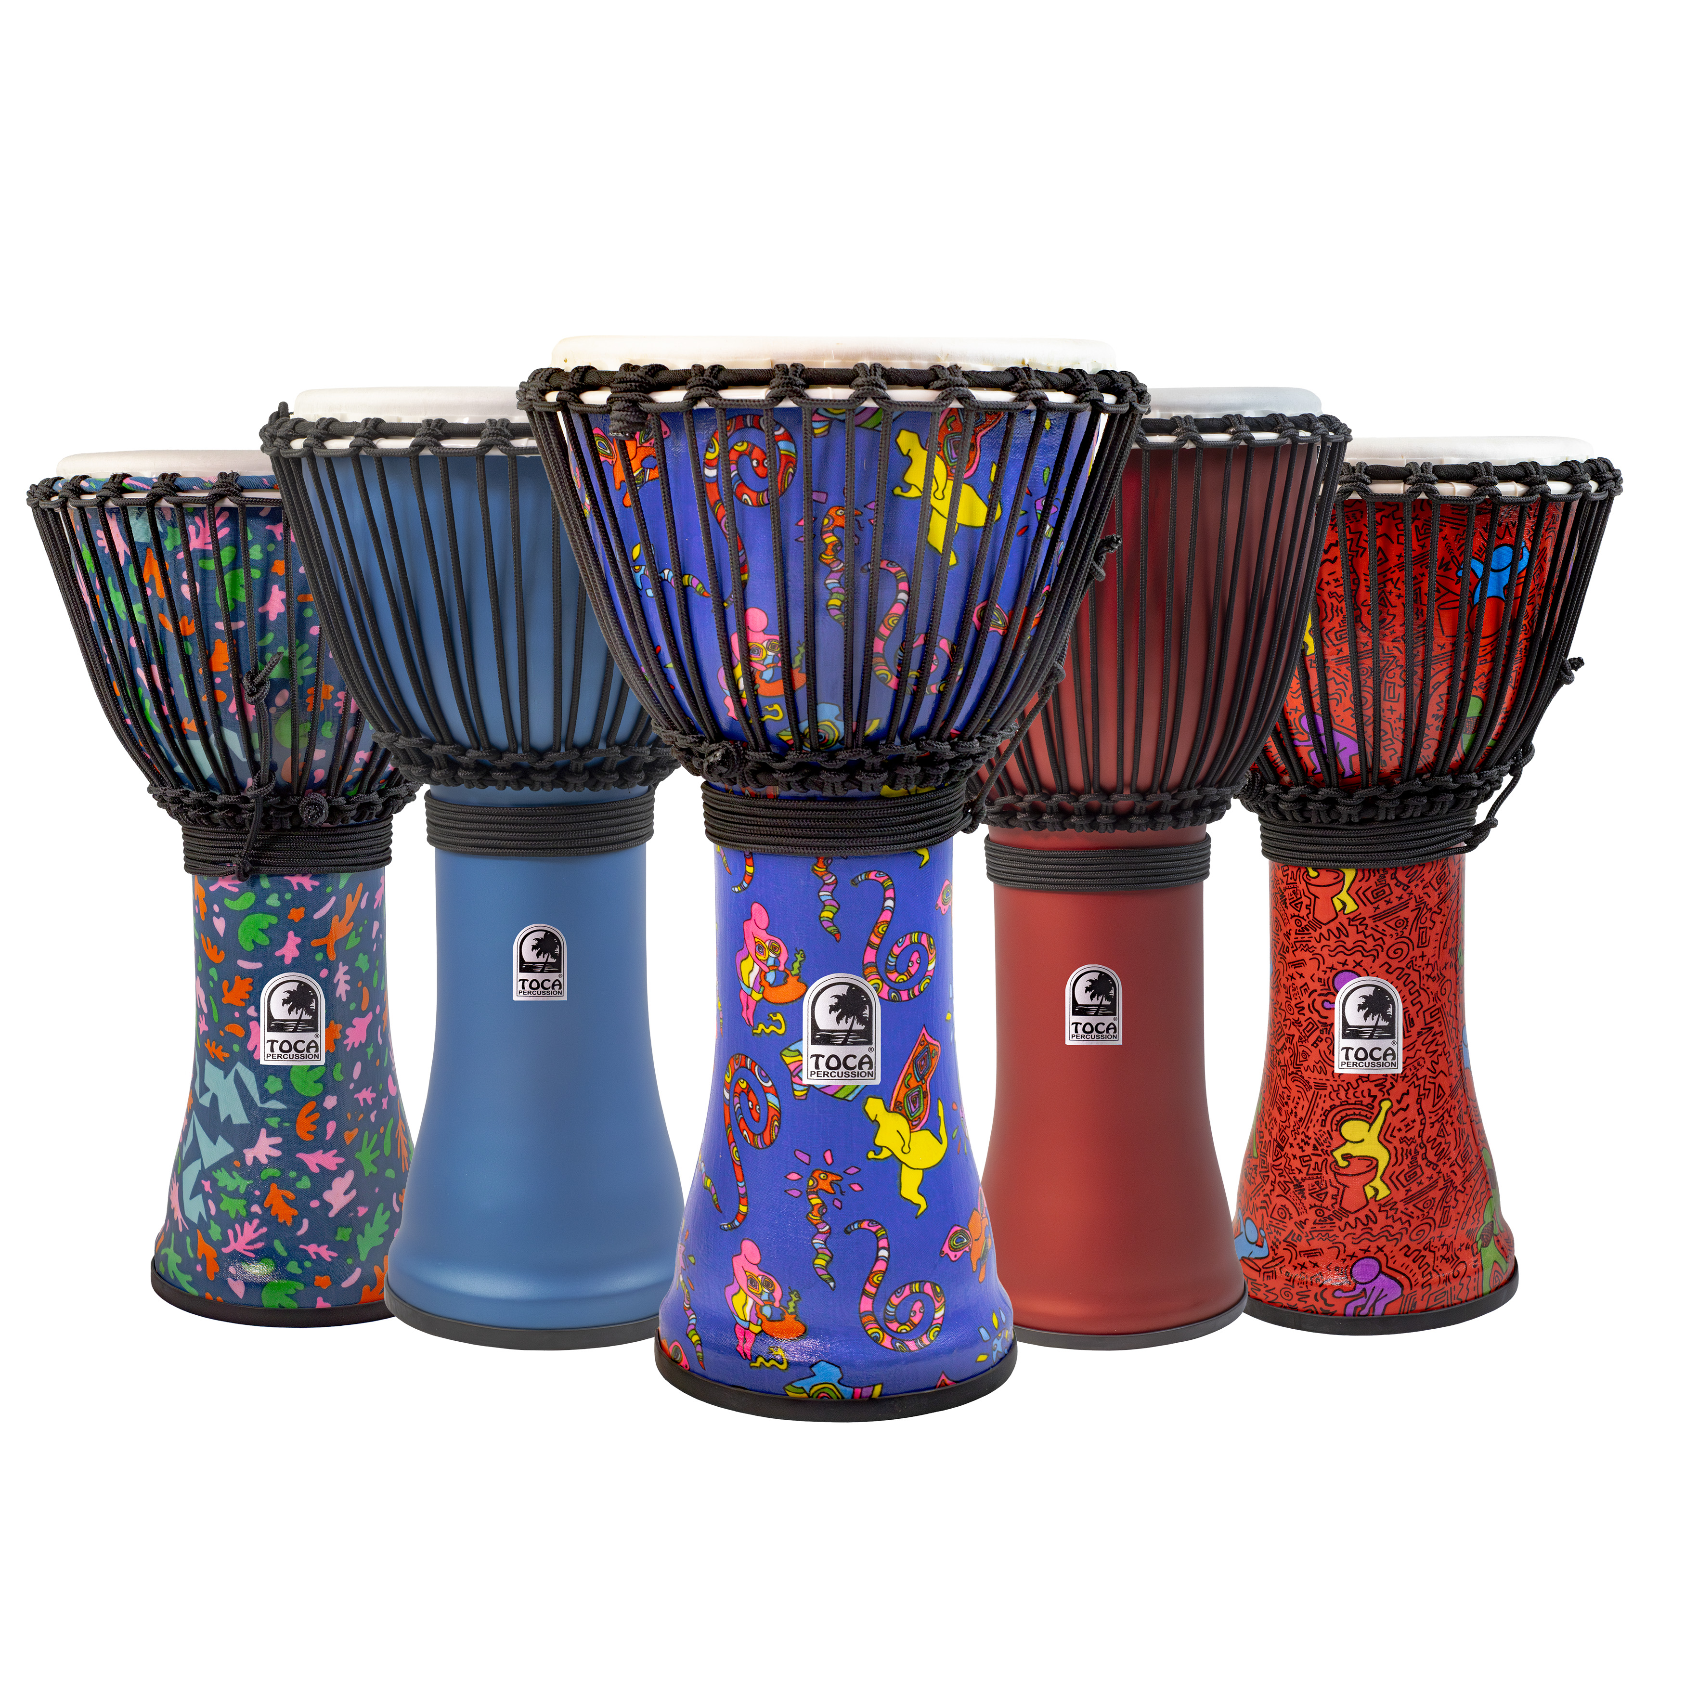Toca Percussion is happy to announce the latest evolution of its *Freestyle Djembes*, featuring the all-new *Matte Series* and *Designer Series*. These new offerings combine cutting-edge design, authentic sound, and rugged durability, making them the perfect choice for drum circle enthusiasts, facilitators, educators, and players at every level.

The *Matte Series* builds upon the acclaimed Custom Deluxe Matte Congas and Bongos introduced in 2024, now reimagined for the Freestyle line. With elegant colors like Grey Skies, Ocrean Blue and Racing Red, this series delivers a sleek, contemporary aesthetic that complements its dynamic sound.

The *Designer Series* takes visual expression to new heights with vibrant, culturally inspired patterns. Bold designs such as Autumn Day, Jam Fest, and Fever Dream bring unique personality and flair to each drum. These djembes showcase a blend of beautiful, fun, and adventurous styles, with even more designs expected in the future, ensuring the series remains fresh and exciting for players and collectors alike.

Crafted with lightweight yet durable seamless synthetic shells, Freestyle Djembes are designed to withstand the rigors of travel and performance. Each drum is rope-tuned and features a hand-selected goatskin head, offering a rich, authentic sound with deep bass tones and piercing highs. The low-stretch Alpine rope with braided cores ensures stable tuning, while the protective rubber, non-slip bottom adds to their practicality and reliability. Available in head sizes of 10", 12", and 14", these drums produce solid, resonant tones that cater to any playing style.

“Toca Freestyle II Djembes have always been about versatility and expression,” said Jim Rockwell, Product Manager for Toca Percussion. “With the Matte and Designer Series, we’re giving players even more ways to stand out—both in terms of sound and style. These djembes are built to perform, inspire, and connect players to the vibrant spirit of drumming.”

tocapercussion.com