**Contact:** Jim Rockwell **FOR IMMEDIATE RELEASE**

RBI Music

**Tel:** 201-247-7224

**Email:** marketing@rbimusic.com

**NEW - Everpour Rainsticks: Long Lasting Sound that Capturing the Rhythm and Culture of Chile**

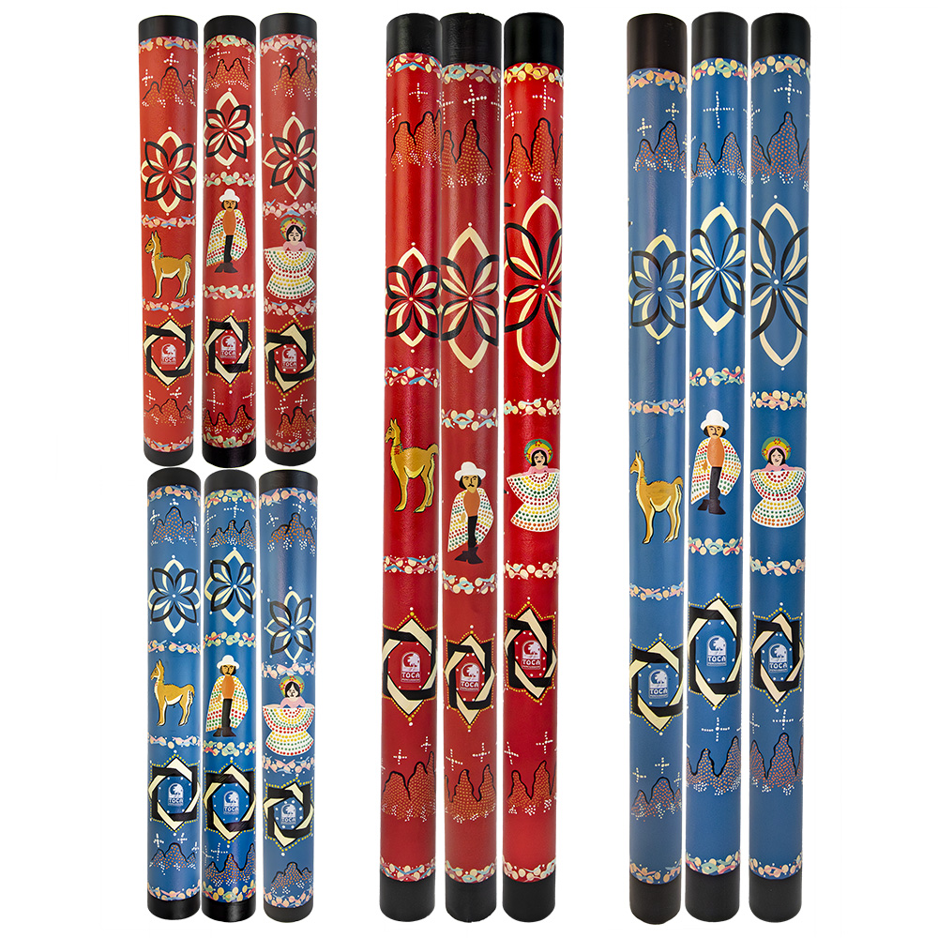Toca Percussion is excited to announce the launch of the *Everpour Rainsticks*, a groundbreaking collection inspired by the rich cultural heritage of Chile. Combining traditional artistry with modern craftsmanship, these rainsticks deliver stunning soundscapes and visuals, making them an essential addition to any musician’s or collector's repertoire.

The Toca Everpour Rainsticks redefine the rainstick experience with their exceptional duration and resonance. The 24-inch models produce mesmerizing rainfall effects lasting for over 30 seconds, while the 48-inch models create immersive, cascading rain sounds for more than 60 seconds.

Honoring the rainstick’s Chilean origins, the *Everpour Rainsticks* feature intricate, hand-painted designs designs that celebrate the country’s traditions and natural beauty. The Cueca models showcase a woman in traditional Chilean dress, paying homage to the vibrant Cueca dance. The Huesa models highlight a man in the iconic Chilean cowboy attire, celebrating the rural *huaso* heritage. Meanwhile, the Guanaco models feature the elegant *guanaco*, a llama-like animal native to Chile and South America. Each design is available in two striking color schemes—red and blue—and comes in both 24-inch and 48-inch sizes, offering a variety of options for musicians, educators, and collectors.

Jim Rockwell, Product Manager for Toca Percussion, added, “We wanted to create a rainstick that not only sounds exceptional but also tells a story. The Everpour Rainsticks are designed to resonate both sonically and culturally, allowing musicians to connect with Chile’s heritage in a meaningful way.”

tocapercussion.com