Contact: Jim Rockwell FOR IMMEDIATE RELEASE
RBI Music
Tel: 201-247-7224
Email: marketing@rbimusic.com

NEW - Toca Custom Deluxe Congas and Bongos in Stunning Margarita Blanca Color

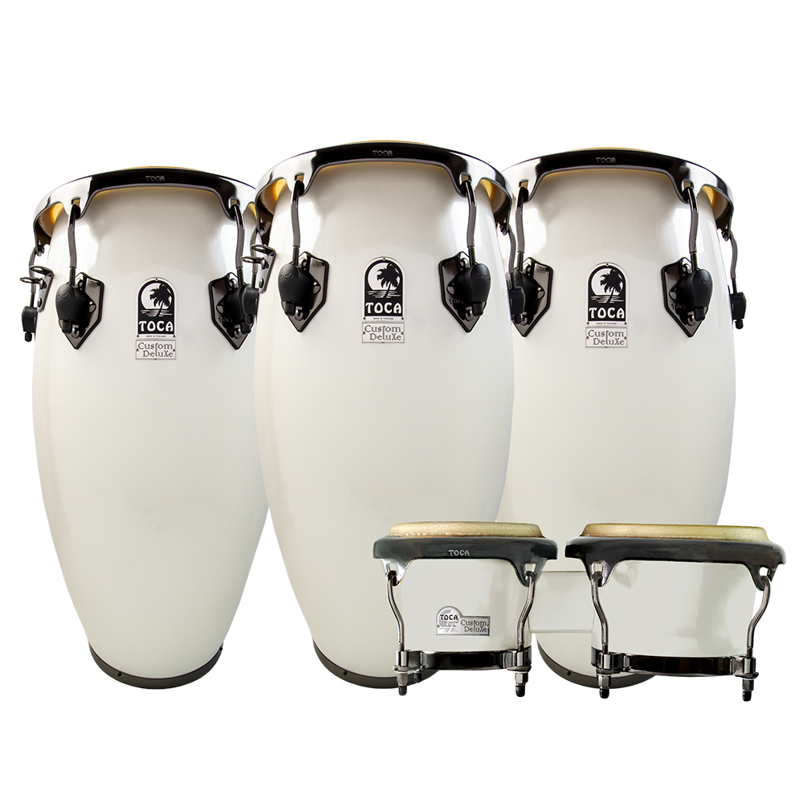
Toca Percussion is proud to unveil its latest release: the Custom Deluxe Congas and Bongos in the breathtaking Margarita Blanca color. Designed for the discerning percussionist, these instruments combine exquisite craftsmanship with exceptional sound quality, making them a standout addition to any performance or studio setup.
The new Margarita Blanca color features luminescent shells that shimmer in a beautiful, translucent white hue, creating a striking visual presence. The congas are further enhanced with sleek black mirror chrome hardware, giving them a modern and sophisticated look. Paired with natural rawhide heads, the result is a visually captivating instrument that doesn't compromise on sound quality.

The Custom Deluxe Congas are crafted from premium 30" tall fiberglass shells with an Afro-Cuban shell shape, providing enhanced volume, resonance, and tonal warmth. This combination of materials and design contributes to a rich, powerful sound that can easily fill any room or stage. The durable black mirror chrome hardware ensures longevity, while the EasyPlay hoop design and 6-lug configuration allow for quick tuning and optimal playability.

The Custom Deluxe Bongos, which accompany the congas in this stunning new collection, feature the same elegant Margarita Blanca finish and offer a matching visual complement to the congas. These bongos maintain the high standards of sound quality and craftsmanship, providing percussionists with a dynamic setup that captures the essence of Afro-Cuban hand percussion traditions.

"We're thrilled to offer percussionists a bold, new option in both aesthetics and performance," said Jim Rockwell, Percussion Product Manager at Toca Percussion. "These drums not only stand out visually but also deliver a sound that is rich, authentic, and versatile.”

tocapercussion.com
rbimusic.com

